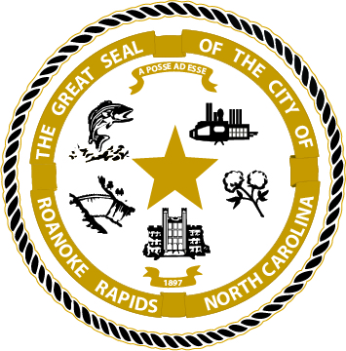

Roanoke Rapids City Council

Work Session

April 6, 2021 5:30 p.m.

Lloyd Andrews City Meeting Hall

Agenda

Call to Order & Invocation

Items for Discussion

- Fire Safety House Tour / Employee Recognition
- Golf Cart Legislation
- CDBG Update
- FY2021-2022 Budget Discussion
- Miscellaneous
- Closed Session to Discuss a matter with the City Attorney as allowed by NCGS 143-318.11 (a)(3).

Adjournment

