Minute Book Page 18214

Minutes of the Roanoke Rapids City Council
The Roanoke Rapids City Council and the Roanoke Rapids Area Planning Board held a joint meeting on Thursday, April 21, 2016 at 5:30 p.m. in the Council Chambers at the Lloyd Andrews City Meeting Hall for the purpose of conducting a public hearing on a request for a Conditional Use Permit.

Roanoke Rapids City Council Members Present:
Emery G. Doughtie, Mayor
Carl Ferebee, Mayor Pro Tem
Ernest C. Bobbitt)
Council Members
Suetta S. Scarbrough)
Carol H. Cowen)
Wayne Smith)

Roanoke Rapids Area Planning Board Members Present:
Greg Browning, Chairman
Terry Buffaloe
Charles B. Landen
Terry Campbell
Henry B. Ford

Others Present:
Joseph Scherer, MPA, MS, City Manager
Gilbert Chichester, City Attorney
Lisa B. Vincent, MMC, NCCMC, City Clerk
Kelly Lasky, Planning & Development Director
Kristyn Anderson, Administrative Assistant I
Chuck Hasty, Police Chief

Call to Order & Invocation

Mayor Doughtie called the Roanoke Rapids City Council meeting to order. He stated the purpose of this meeting is to conduct a joint public hearing with the Roanoke Rapids Area Planning Board concerning a request from MaSuKi, Inc. for a Conditional Use Permit to amend the Villages at Cross Creek Planned Unit Development Permit and Zoning Map.
Minute Book Page 18215

Chairman Browning called the Roanoke Rapids Area Planning Board meeting to order.

Mayor Doughtie provided the invocation.

Adoption of Agenda

Mayor Doughtie asked City Council members about any known conflicts of interest with respect to the matter before them this evening.

Mayor Pro Tem Ferebee stated on March 24, 2016, he attended a meeting at City Hall where Mark Gregory stated his intent to apply for a Conditional Use Permit for a substantially revised plan for an apartment development on his property. He stated in response to Mr. Gregory’s statement, staff advised him of the application process and procedures. Mayor Pro Tem Ferebee stated on April 4, 2016, he visited the site to conduct a visual inspection of the property. Mayor Pro Tem Ferebee stated he remains an impartial decision-maker and intends to make a decision based upon competent, material and substantial evidence presented during the public hearing.

Mayor Doughtie stated on March 24, 2016, he attended a meeting at City Hall where Mark Gregory stated his intent to apply for a Conditional Use Permit for a substantially revised plan for an apartment development on his property. Mayor Doughtie stated he remains an impartial decision-maker and intends to make a decision based upon competent, material and substantial evidence presented during the public hearing.

Councilman Smith stated he does not have any conflicts. He stated on March 24, 2016, he attended a meeting at City Hall where Mark Gregory stated his intent to apply for a Conditional Use Permit for a substantially revised plan for an apartment development on his property. He stated in response to Mr. Gregory’s statement, staff advised him of the application process and procedures. He stated on March 31, 2016, he visited the site to conduct a visual inspection of the property. Councilman Smith stated he remains an impartial decision-maker and intends to make a decision based upon competent, material and substantial evidence presented during the public hearing.

Councilwoman Scarbrough stated on March 24, 2016, she attended a meeting at City Hall where Mark Gregory stated his intent to apply for a Conditional Use Permit for a substantially revised plan for an apartment development on his property. She stated in response to Mr. Gregory’s statement, staff advised him of the application process and procedures. She stated on March 31, 2016, she visited the site to conduct a visual inspection of the property. Councilwoman Scarbrough stated she remains an impartial
Minute Book Page 18216

decision-maker and intends to make a decision based upon competent, material and substantial evidence presented during the public hearing.

Councilman Bobbitt stated on March 24, 2016, he attended a meeting at City Hall where Mark Gregory stated his intent to apply for a Conditional Use Permit for a substantially revised plan for an apartment development on his property. He stated in response to Mr. Gregory’s statement, staff advised him of the application process and procedures. Councilman Bobbitt stated he remains an impartial decision-maker and intends to make a decision based upon competent, material and substantial evidence presented during the public hearing.

Councilwoman Cowen stated on March 24, 2016, she attended a meeting at City Hall where Mark Gregory stated his intent to apply for a Conditional Use Permit for a substantially revised plan for an apartment development on his property. She stated in response to Mr. Gregory’s statement, staff advised him of the application process and procedures. Councilwoman Cowen stated she remains an impartial decision-maker and intends to make a decision based upon competent, material and substantial evidence presented during the public hearing.

Councilman Smith asked City Attorney Chichester to clarify that only two Council members at a time attended the meetings with Mr. Gregory.

City Attorney Chichester stated it is his understanding that even though the Council members met with Mr. Gregory, no more than two of them were together at one time; therefore, these were not official meetings that required legal notice.

Motion was made by Councilwoman Scarbrough, seconded by Councilman Smith and unanimously carried to adopt the agenda for the April 21, 2016 joint meeting of the Roanoke Rapids City Council and the Roanoke Rapids Area Planning Board.

Chairman Browning asked Planning Board members if anyone needed to recuse themselves.

There being no one requesting to be recused, motion was made by Board Member Landen, seconded by Board Member Buffaloe and unanimously carried to adopt the agenda for the April 21, 2016 joint meeting of the Roanoke Rapids Area Planning Board and the Roanoke Rapids City Council

Minute Book Page 18217

Joint Public Hearing
Conditional Use Permit Request from MaSuKi, Inc.

Mayor Doughtie opened the public hearing and Planning & Development Director Lasky, having been duly sworn, presented the following staff report:

STAFF REPORT

To: Roanoke Rapids City Council and Roanoke Rapids Area Planning Board
From: Kelly Lasky, Planning & Development Director/s/
Re: Conditional Use Permit to Amend the Villages at Cross Creek Community Planned Unit Development Permit and Zoning Map to Change approximately 17 acres to PUD R-3 to Permit a Multi-Family Apartment Development with Amenities
Date: April 15, 2016

EXECUTIVE SUMMARY
To amend the current Villages at Cross Creek Conditional Use Permit and Planned Unit Development (PUD) Zoning Map by rezoning approximately 17.04 acres from PUD B-4, R-12, and R-40 to PUD R-3 to allow a multi-family residential use, subject to design specified in associated preliminary site plan titled “Highway 125 Apartments Sketch” which consists of six (6) residential buildings (24 units per building) for a maximum density of 144 residential units. No modifications or exceptions to the City’s development standards are being requested. The use of the property as a Planned Unit Development (PUD) is a use that is permitted with the approval of a Conditional Use Permit.

SUBJECT PARCEL VICINITY MAP
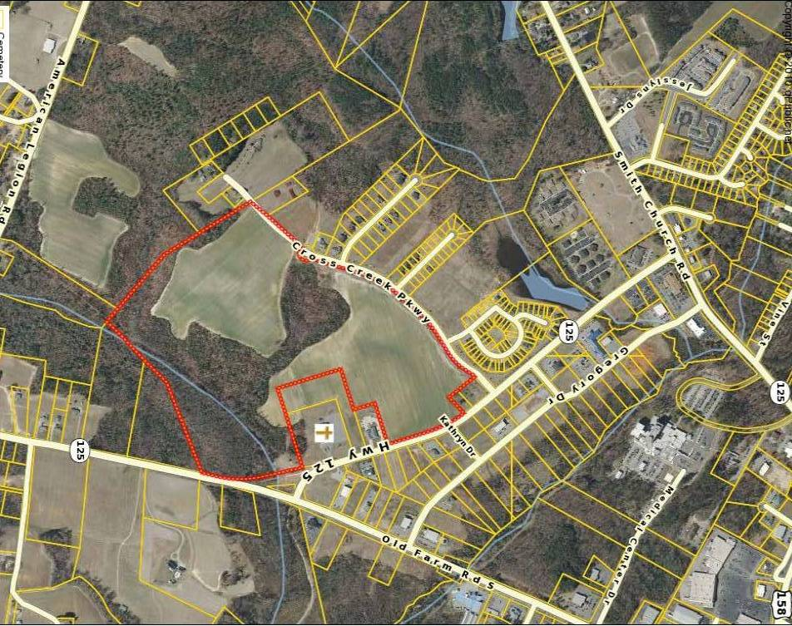
The subject parcel is located within the Villages at Cross Creek subdivision, located along NC Hwy 125 between Old Farm Road South and Smith Church Road. The area for PUD R-3 Zoning consideration is a 17.04 acre portion of a 104 acre tract (Halifax County Tax Parcel 1205276) located adjacent to the eastern right of way of Cross Creek Parkway at NC Hwy 125. The 17 acre site is bordered by the property developed as Good News Baptist Church of Roanoke Rapids, the City of Roanoke Rapids Fire Station #2, and remaining 84 acres of MaSuKi, Inc. owned property zoned for single-family development.
Vicinity Map 104 acre tract outlined in red

Minute Book Page 18218

BACKGROUND & SITE INFORMATION

- Applicant | Mark Gregory, President  MaSuKi, Inc.
- General Location | NC Hwy 125 between Old Farm Road South and Smith Church Road
- Existing Land Use | Vacant, undeveloped
- Existing Zoning District(s) | Villages at Cross Creek PUD Zoning District (R-3, R-6, R-12, R-40, B-4)
- Existing Zoning Conditions | The Villages at Cross Creek PUD was approved as a Conditional Use Permit by City Council on March 22, 2005 and later revised August 18, 2015 subject to the following stipulation:  The Planned Unit Development shall be developed in accordance with the PUD plat prepared by M. S. Consultants, Inc., entitled “Villages @ Cross Creek PUD Zoning Map – City of Roanoke Rapids, Halifax County, North Carolina”, dated February 10, 2005, and revised July 6, 2015 as kept in the Office of Planning and Development for greater reference.
- Proposed Zoning District(s) | PUD R-3, Residential (17.04 acres)
- Proposed Zoning Conditions | In addition to existing zoning conditions, the design and site layout as indicated on the associated Preliminary Development Plan including:  - There shall be a maximum of 144 multi-family residential units divided among six (6) residential buildings  - Required screening and buffering between uses shall be installed/planted at time of building construction – prior to occupancy  - Obtain NCDOT driveway and access agreements prior to construction  - Proposed swimming pool shall be reviewed for compliance by Halifax County Health Department  - Administrator may authorize occupancy with a performance guarantee in accordance with Article IV furnished to the City in the amount of one hundred twenty-five percent (125%) of the reasonably estimated cost of completion at the time the performance guarantee is issued.
- 2014 Future Land Use Plan Designation (Map 24) | High Density Residential (HDR) which is defined as R-3 Residential Zoning with a desired density of 8.5 dwelling units per acre (Section 6, p 5)
- Within City Limits | Yes
- School District | Weldon
- Site Plan | Yes – to modify 2005 Villages at Cross Creek PUD Map concept plan for 17 acre site area for development as multi-family residential

Minute Book Page 18219

PUD MAP REZONING AREA Please refer to attached maps for “Area” locations. The 17 acre area requested for PUD, R-3 District currently includes three zoning classifications within the 2005 Villages at Cross Creek PUD Zoning Map: B-4, Commercial (approx. 1 acre of Area 8 and approx. 2 acres of Area 7); R-12, Residential (approx. 7 acres of Area 6); and R-40, Residential (approx. 7 acres of Area 5). All other PUD Zoning Map areas, including the remaining 87 acres (of the 104 acre parent tract) of property owned by MaSuKi, Inc., will retain current PUD zoning classifications.
2005 VILLAGES AT CROSS CREEK PUD ZONING MAP
The 104 acre MaSuKi parcel is outlined in black.

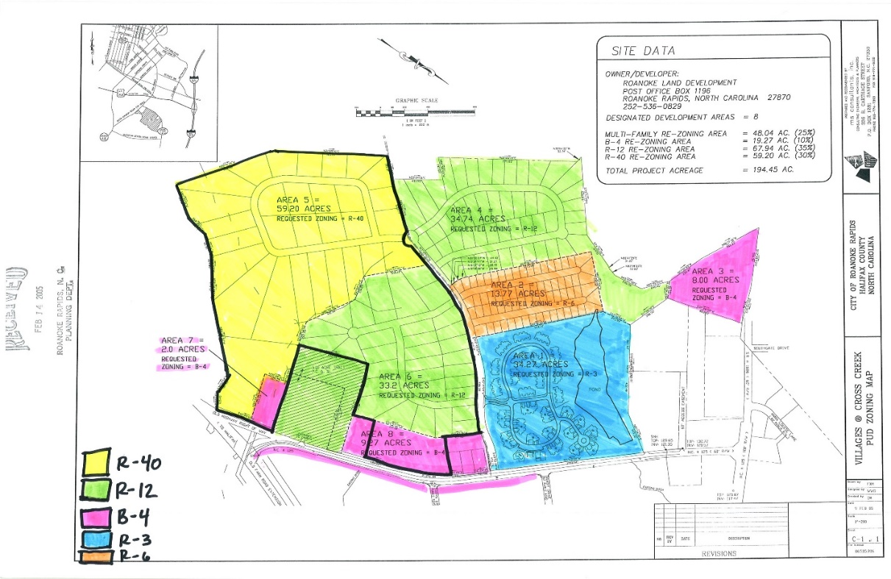
2015 Revised VILLAGES AT CROSS CREEK PUD ZONING MAP
The 17 acre site for “PROPOSED R-3” is shaded in light blue.
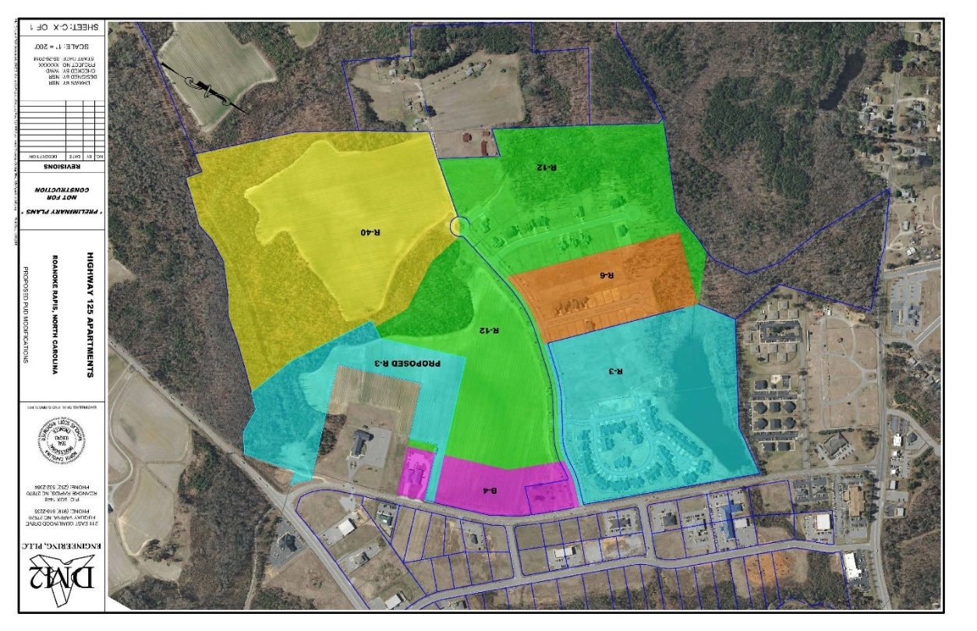

2015 Revised VILLAGES AT CROSS CREEK PUD ZONING MAP
The 17 acre site for “PROPOSED R-3” is shaded in light blue.

Minute Book Page 18220

PROJECT SUMMARY - Proposed Multi-Family Development (2016)
This is a request to change an existing Conditional Use Permit and Villages at Cross Creek Planned Unit Development (PUD) Zoning Map initially approved by City Council March 22, 2005, revised August 18, 2015. The PUD R-3, Multi-family Residential District is requested to accommodate a multi-family development proposal consisting of six (6) residential buildings (a total of 144 residential apartments) and community amenities. This request is REVISED from a 2014 Application by MaSuKi, Inc.

The current request by MaSuKi, Inc. includes a site plan to construct six (6) multi-family residential buildings containing a total of 144 residential units (24 units per building). Direct access is proposed via NC Hwy 125. The site development plans include community amenities:

- 3,200 square foot clubhouse
- swimming pool
- picnic area
- sidewalks
- private garage storage
- on-site property management
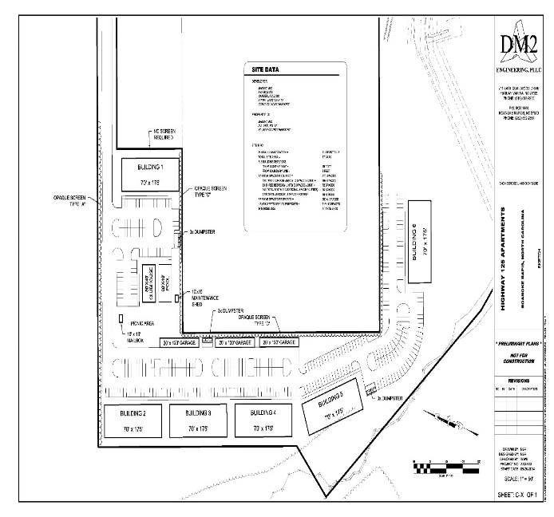

CRITERIA FOR CONSIDERATION IN REVIEWING CONDITIONAL USE PERMITS

Planning and Development staff has made the following findings concerning this request:
Minute Book Page 18221

SECTION I:

1. The requested permit is within its jurisdiction according to the table of permissible uses; or
Analysis: The requested permit is within its jurisdiction subject to the approval of a Conditional Use Permit. As indicated in the Table of Permissible Uses (Section 151-149), a planned unit development (use Classification 30.000) is the only permissible use of a PUD zone and planned unit developments are permissible only in such zones. The Villages at Cross Creek PUD map was approved by City Council on March 22, 2005 and later revised upon request on August 18, 2015. Planned Unit Development Districts are designed to combine the characteristics of multiple zoning districts, including high and low residential densities, commercial and industrial uses.

2. The application is complete; or
Analysis: the application is complete.

3. If completed as proposed in the application, the development will comply with all requirements of The Land Use Ordinance; or
Analysis: The Development will comply with all of the requirements of the Land Use Ordinance if completed as proposed in the application. The site plan will be required and will go through the formal Development Review Committee process to ensure compliance. Once the site plan has been approved, the building plans are reviewed then a building permit will be issued. Development standards include, but are not limited to, ordinances regulating the following conditions:
- Parking Facilities:
  - Required width of parking area aisles and driveways
  - Parking space dimensions
  - General design requirements and surfacing
  - The minimum required parking spaces be provided for the residential development;
  - Shade trees in parking areas
- Vehicle accommodation areas shall be designed so that sanitation, emergency, and other public service vehicles can serve such developments;
- Lighting Requirements:
  - Sufficient illumination to ensure the security of property and the safety of persons using driveways, sidewalks, parking lots and other common areas and facilities;
  - All entrances and exits in substantial buildings used for non-residential purposes and in multi-family residential dwellings shall be adequately lighted to ensure the safety of persons and the security of the building.
  - Lighting shall be achieved in a manner that would not substantially interfere with the use or enjoyment of neighboring properties.
- Sites for and Screening of Dumpsters;
- Swimming pool barrier provided per Ordinance and NC State Building Code;

SECTION II:
The following seven items were also considered when evaluating item #4 (a), (b), (c) and (d) that follows:

1: ingress and egress to the lot and proposed structures, especially by pedestrians and automobiles, is safe and convenient in terms of access and traffic flow; and,
Analysis: this is probably true; the preliminary site layout has direct access to NC Hwy 125. Traffic control measures and access on NC Hwy 125 are under the jurisdiction of the North Carolina
Minute Book Page 18222

Department of Transportation and subject to its approval. Pedestrian sidewalks are provided around the perimeter of the parking lots adjacent to the residential apartment buildings.

2: off-street parking and loading affects adjacent property (in terms of traffic generation, economic
impact, noise, glare and odor) similar to uses permitted in that zoning district; and,
Analysis: this is probably true; as currently proposed, the off-street parking requirements for the multi-family residential are provided. The Ordinance requires one-and-a-half (1.5) spaces for each one and two-bedroom units; two 2 spaces for each unit having three or more bedrooms; plus one (1) space for every four units. The minimum required parking for the residential development as proposed is 270 parking spaces; (based on 108 two-bedroom units; 36 three-bedroom units and 144 total units / 4 spaces). Additional parking is being provided for the clubhouse at one space per 200 square feet. The minimum required parking for the entire development, as proposed, is 286 parking spaces.
The requested permit is of similar land use type to properties along NC Hwy 125. There are other multi-family residential developments accessed by NC Hwy 125 in the vicinity of the proposed development. The proposed development may create some changes in the current traffic patterns. However, all proposed construction and site plans will be formally evaluated by city staff, the Development Review Committee, including NC Department of Transportation to ensure a proper design. The Development Review Committee includes the Sanitary District, NCDOT, Public Works, NC Dominion Power, Fire Marshal and Code Enforcement.
The number of dwelling units proposed for construction is 144 units divided among six buildings. According to the Institute of Transportation Engineers Trip Generation Manual (7th edition) the residential apartment use proposed is expected to average 6.72 vehicular trips per day per dwelling unit. Based on this manual, which is utilized by NCDOT, approximately 968 vehicular trips per day could be added to NC Highway 125.
3: refuse disposal affects adjacent property similar to uses permitted in that zoning district; and,
Analysis: This is probably true; the refuse collection requirements of the City of Roanoke Rapids shall apply to the development. The preliminary site layout shows three separate dumpster locations. Dumpsters are required to be properly screened according to the ordinance.

4: utilities are available; and,
Analysis: This is probably true; all utilities are currently available for the site. Connections and extensions shall be coordinated with appropriate entities. There are no specific utility considerations that should negatively impact this property at the present time. All utilities are readily available to the area. The development will be subject to impact or user fees as established by the appropriate utility entities.

5: the type, dimensions and character of screening and buffering satisfactorily screens adjacent property; and,
Analysis: This is probably true; the parcel of land is zoned PUD and will be compatible to the adjoining uses. The Land Use Ordinance requires screening and buffering between neighboring land uses to provide an impression of separation of spaces by lessening any potential visual pollution that may otherwise occur in the urbanized area. Screening is necessary to safeguard public health, safety and welfare.

Minute Book Page 18223

The preliminary site layout for the proposed development is adjacent to several land use types requiring various intensities of screening. The Ordinance requires the multi-family development to install the required screening during the time of building construction. The Ordinance requires Opaque Screen Type A between the requested land use and the existing permitted single-family residential land use (Cross Creek community). The Ordinance requires Opaque Screen Type C between the requested land use and the adjacent church property. The Ordinance does not require screening between the requested land use and the existing adjacent fire station. Descriptions of the screening types are provided below.
Opaque Screen, Type "A". A screen that is opaque from the ground to a height of at least eight feet. An opaque screen is intended to exclude completely all visual contact between uses and to create a strong impression of spatial separation. The opaque screen may be composed of a wall, fence, landscaped earth berm, planted vegetation, or existing vegetation. Compliance of planted vegetative screens or natural vegetation will be judged based on the average mature height and density of foliage of the subject species or field observation of existing vegetation. The screen must be opaque in all seasons of the year. Suggested planting patterns that will achieve this standard are included in Appendix B of the Land Use Ordinance.
Opaque Screen, Type "C". A screen that is opaque to a height of at least eight (8) feet. An opaque screen is intended to exclude completely all visual contact between uses and to create a strong impression of spatial separation. The opaque screen may be composed of a wall, fence, or earth berm.
6: signs and lighting affect adjacent property similar to uses permitted in that zoning district; and,
Analysis: This is probably true; all signage will require a sign permit. All parking areas and buildings shall be sufficiently illuminated by the developer to meet Land Use Ordinance requirements.

7: required yards, open space and existing trees and other attractive and natural features of the land are preserved.
Analysis: This is probably true; the site was originally approved for residential development and residential development is proposed. The proposed site plan includes the required yards and open space based on required building setbacks. There are no existing trees identified for preservation within the project area as the land is undeveloped and cleared. Any proposed changes are subject to review by Staff.

SECTION III:
Given the preceding, the Staff has made the following findings concerning this request:

4: If completed as proposed, the development, more probably than not:

(a) Will not materially endanger the public health or safety; or
The staff has determined this is probably true; the residential use of the property does not endanger the public health or safety of the community. All safety and health codes will be enforced. The parking lot allows adequate access for vehicular movement and emergency service vehicles. The residential buildings will be required to have automatic sprinkler system protection. The development shall be required to comply with all applicable federal, state and local codes and ordinances. An assessment of the previously referenced seven items used to evaluate 4 (a), (b), (c) & (d) indicates no specific endangerment to the
Minute Book Page 18224

public health or safety that is not adequately addressed.

(b) Will not substantially injure the value of the adjoining or abutting property; or
The staff believes this is probably true. The site is adjacent to non-residential uses (church, fire station) that are permissible in residential districts. The development requires buffering and screening in compliance with Ordinance. The multi-family residential use is similar to other uses along NC Hwy 125. Staff cannot determine the impact of value this proposed use would have on surrounding properties however based on the seven additional items used to evaluate 4, (a) (b) (c) & (d) any potential negative effects on adjoining or abutting property should be minimal.

(c) Will be in harmony with the area in which it is to be located; or
The staff has determined this is probably true; a Planned Unit Development (PUD) is planned and developed as an integral unit, and consisting of a combination of principal uses that could not be combined in any other district other than a planned unit development district. The residential use as proposed will be in harmony with the existing surrounding uses in the area based on the previously referenced seven items used to evaluate items 4 (a), (b), (c) & (d).

(d) Will be in general conformity with the Comprehensive Development Plan, Thoroughfare Plan, or other plan officially adopted by the City Council.
The staff has determined this is probably true. The proposed request for an amendment to the PUD zoning map is considered to be reasonable. Reasonableness is determined by considering the size of the area, any special conditions or factors regarding the area, the consistency of the zoning with the land use plan, the degree of the change in the zoning, the degree it allows uses different from the surrounding area, and the relative benefits and/or detriments for the owner, the neighbors, and the surrounding community.

City of Roanoke Comprehensive Plan (2014)
Section 4 describes the Existing Land Use Patterns of the City’s Planning & Zoning Jurisdiction, which includes a total land area of 7,998.21 acres. Single-family residential land use is largest category in the jurisdiction having 2,146.86 acres (26.84% of total land). Multi-Family Residential land use accounts for 306.03 acres (3.83% of total land). Section 5, p 11-13, states that the highest per acre tax value within the corporate limits is multi-family development. According to Table 27 Roanoke Rapids Tax Values within Corporate Limits, Multi-Family Residential is appraised at $849,192 per acre and Single-Family Residential is appraised at $337,000 per acre. Section 6, p 5, indicates that the future land use designation for the subject property is High Density Residential (HDR) which is defined as R-3 Residential Zoning with a desired density of 8.5 dwelling units per acre.

The Comprehensive Development Plan states the following policies should be considered:

I.1 Support infill development. Infill development is development or redevelopment of land that has been bypassed, remained vacant, undervalued and/or is underused as a result of continuing urban development process. Use of such lands for new housing and/or other urban development is considered a more desirable alternative than to continue to extend the outer development pattern laterally and horizontally thus necessitating a higher expenditure for capital improvements than would be required for infill development.
Minute Book Page 18225

I.19 Consider allowing different housing densities to abut one another as long as proper buffering and design is provided as needed and traffic generated by such land use does not mix within the neighborhood.
I.20 Encourage developers to utilize thoroughfares and natural topographic features to define the boundaries of a neighborhood and concentrate higher intensity uses at the outer boundaries of the neighborhood.

NCDOT Comprehensive Transportation Plan
NC Hwy 125 is designed as a Major Thoroughfare.

SUMMARY OF PROCESS AND ACTIONS TO DATE

Notification
On April 6, 2016, Notice of the public hearing on the proposed request was mailed to property owners (121) within 100 feet of the subject parcel and to all property owners within the Villages at Cross Creek PUD. The notice was published on the City’s website and posted on the subject property. The notice was advertised in the Daily Herald on April 10 and April 17, 2016. The notice was advertised on the RRSPIN website’s City Page section.

EXHIBITS
The following documents are incorporated and attached to this staff report:
- Villages at Cross Creek Background (Permitting History & Approvals)
- Conditional Use Permit Application
- Proposed PUD Modification Map
- Overall PUD Map
- Preliminary Site Layout
- Sketch
- Highway 125 Apartments Sketch with Site Data

SECTION IV:
The applicant has addressed the requisite questions, which must be answered by the City Council in the application. It is your obligation to ensure each has been adequately addressed after hearing all parties prior to rendering your recommendation to City Council.

Planning & Development Department Review
After a complete review of the information submitted to date by the applicant, it is the Planning Staff’s opinion that the request satisfactorily meets the requirements of Section 151 – 94 of the Land Use Ordinance. The Staff recommends, however, if approval of the Permit is recommended, it is subject to the following stipulations:

- Additional detailed construction drawings and building plans shall be provided to the Planning and Development staff, when requested, to determine compliance with any one or more of the provisions of the Land Use Ordinance, Building Code, Fire Code, City Code or other applicable required code or ordinance.
- Obtain all necessary approvals from NCDOT and Health Department prior to issuance of building permits for driveway, buildings, swimming pool.
Minute Book Page 18226

- Required screening and buffering between land uses shall be installed prior to issuance of a Certificate of Occupancy.
- In addition to existing zoning conditions, the design and site layout as indicated on the associated Preliminary Development Plan including: There shall be a maximum of 144 multi-family residential units divided among six (6) residential buildings
- Administrator may authorize occupancy with a performance guarantee in accordance with Article IV furnished to the City in the amount of one hundred twenty-five percent (125%) of the reasonably estimated cost of completion at the time the performance guarantee is issued.

Requested Action by Planning Board
The Planning Board has several options regarding this Conditional Use Permit application.

(1) recommendation for approval of the request as submitted;
(2) recommendation for approval of the request, subject to certain stated conditions;
(3) recommendation for denial of the request.

Please discuss the application and provide a motion, second and a vote.
Requested Action by City Council
Please refer to the attached Work Sheet to discuss the application and provide a motion, second and a vote concerning the Findings of Fact and a Final Decision.

Villages at Cross Creek - Background (Permitting History & Project Approvals)
The Villages at Cross Creek was initially approved as one planned unit development project comprehensively addressing traffic, residential density, utilities and infrastructure, and other considerations. During 2005, the City Council approved a Conditional Use Permit authorizing the Villages at Cross Creek as a Planned Unit Development District with various zoning districts to include multi-family, single-family and commercially zoned areas fronting North Carolina Hwy 125. The Villages at Cross Creek PUD was approved as a Conditional Use Permit by City Council on March 22, 2005 subject to the following stipulations:
1. The Planned Unit Development shall be developed in accordance with the PUD plat prepared by M. S. Consultants, Inc., entitled “Villages @ Cross Creek PUD Zoning Map – City of Roanoke Rapids, Halifax County, North Carolina”, dated February 10, 2005, as kept in the Office of Planning and Development for greater reference.
2. Additional detailed construction drawings shall be provided to the Planning and Development staff, when requested, to determine compliance with any one or more of the provisions of the Land Use Ordinance, Building Code, Fire Code, City Code or other applicable required code or ordinance.
3. Final plat approval of the entire PUD or any phase thereof may be conditioned by developer providing an acceptable performance bond or other security to the City in the amount of 125% of the actual cost of all required improvements in compliance with Section 151-61 of the Land Use Ordinance in lieu of actual installation of improvements. All requirements shall be fulfilled within not more than 12 months after final plat approval.

The PUD was approved to be composed of residential areas encompassing multi-family, single family and commercial uses. At the time of development approval, the site consisted of a single parcel of land 194.45± acres in size. The site was approved to be composed of eight (8) designated individual development areas. The approved PUD map included 48.04 acres of high density multi-family R-3 & R-6
Minute Book Page 18227

residential property; 59.20 acres of single family R-40 residential property; 67.94 acres of single family R-12 residential property and 19.27 acres of B-4 business commercial property.

The high density multi-family R-3 and R-6 residential areas are to be developed with patio homes and town homes. Initial plans were approved for thirty-two (32) town home buildings with a total of one hundred-two (102) units and one club house, swimming pool and tennis court.

August 18, 2015 Approved Amendment to Permit and PUD Zoning Map
Approximately 11 acres of property (portion of Halifax County Parcel 1205725) located along Smith Church Road extending east towards the creek was subdivided and permanently removed from the Villages at Cross Creek PUD Zoning Map. The 11 acres of property were zoned PUD B-4 (Area 3 = 8 acres) and PUD R-12 (Area 4 = approx. 3 acres). Subdivision from the overall Villages at Cross Creek PUD Zoning Map was requested for the adjacent property owner to move forward with a proposal to expand the existing, adjacent Crestview Memorial Cemetery. The amendment to the existing Conditional Use Permit did not change the zoning classifications or permissible uses within the Villages at Cross Creek.

The PUD Map revisions approved August 18, 2015 reduced the Total Project Acreage to 182.95 acres, which included 48.04 acres of high density multi-family R-3 & R-6 residential property; 59.20 acres of single family R-40 residential property; 64.44 acres of single family R-12 residential property and 11.27 acres of B-4 business commercial property.

Planning & Development Director Lasky also highlighted the following memorandum from Police Chief Hasty:

MEMORANDUM

To: Kelly Lasky, Planning & Development Director
From: Chuck Hasty, Chief of Police Department/s/
Date: April 18, 2016
Reference: Proposed Apartment Development on NC Hwy 125 at Cross Creek Subdivision

On April 14, 2016, the above referenced project was presented for preliminary departmental review by Mark Gregory, President of MaSuKi, Inc. The following comments are provided in response to the Police Department’s review of the safety and security measures expected for the proposed Apartment Development at the Cross Creek Subdivision.

- Lighting – All roads, driveways, sidewalks, parking lots and other common areas and facilities shall be sufficiently illuminated to ensure the security of property and the safety of persons using such roads, driveways, sidewalks, parking lots and other common areas and facilities. All entrances and exits in substantial buildings used for non-residential purposes and in multi-family residential dwellings shall be adequately lighted to ensure the safety of persons and the security of the building. Lighting shall be achieved in a manner that would not substantially interfere with neighboring properties.

Minute Book Page 18228

- Video Surveillance – The Police Department accepts the applicant’s proposal for video surveillance to monitor the security of property and safety of residents. Adequate surveillance of premises is encouraged to deter criminal activity and create a sense of safety for residents and their guests.
- On-Site Management and Applicant Background Verification – The proposed on-site property management and applicant screening process will ensure the developer’s accountability for responsible tenants and protection of residents. The developer states that each apartment occupant that is 18 years and older must complete an application and undergo a credit and criminal background check, including search of registered sex offender database. The process of background verification is not limited to the primary lease-holder; it includes all 18 year old and older persons (as individuals or part of a family) who intend to make residence of an apartment.

Analysis of Motor Vehicle Crash Data
The City of Roanoke Rapids Police Department researched and analyzed vehicular incident reports occurring during a five-year period from all reported vehicular crashes along NC Hwy 125 between Old Farm Road South and Smith Church Road. The intent was to determine the frequency of motor vehicle collisions and to identify the risk of potential when considering the multi-family development proposal that would generate additional traffic to this corridor of NC Hwy 125. The results of the analysis show there have been only 34 vehicular accidents within a five-year period along this section of NC Hwy 125 (average of nearly seven (7) wrecks per year and 0.58 wrecks per month). In comparison to the total number of wrecks within the City Limits, there are over 1,000 wrecks per year and an average of 90 wrecks per month. Based on analysis of the crash data and comparison to the total count of wrecks within the City Limits, the Police Department concludes that this section of NC Hwy 125 accounts for less than 1% annual city-wide wrecks, which is very low compared to the City as a whole. Characteristics of the crash data were reviewed to determine location, injuries and results of the crashes; the following table reflects the injuries reported. The majority of crashes resulted in no bodily injuries to passengers.

Characteristics of 5-YR Crash Data for NC Hwy 125 (Old Farm Rd. S. & Smith Church Rd.)
From Halifax Central Communications (January 2011 – April 14, 2016)
Injuries from Crashes | Number of Reports | Percent of Total
Unknown | 3 | 9%
Hit and Run | 5 | 15%
Injury | 5 | 15%
No Injury | 21 | 61%
TOTAL | 34 | 100%

Planning & Development Director Lasky also pointed out that no significant impacts to wetlands are anticipated as a result of this development.

Mayor Pro Tem Ferebee asked Planning & Development Director Lasky to point out on the map the proposed ingress and egress for the development.

Planning & Development Director Lasky pointed out the location on an aerial map which she indicated is adjacent to Fire Station No. 2. She did indicate that the final access is not required at this time but we know this is a general location.

Minute Book Page 18229

Mayor Pro Tem Ferebee stated they are not using Cross Creek Parkway as access.

Planning & Development Director Lasky stated no.

Mayor Pro Tem Ferebee stated it was mentioned that approximately 968 vehicular trips per day could be added to NC Highway 125. He asked if the highway can currently handle the increase.

Planning & Development Director Lasky stated it was designed to handle thousands of vehicles.

Mayor Pro Tem Ferebee stated we were shown two sets of wetlands. He asked if this request meets the required distance from the wetlands.

Planning & Development Director Lasky stated yes.

Mayor Pro Tem Ferebee asked if we have heard from Good News Baptist Church.

Planning & Development Director Lasky stated members of the church are present tonight.

Councilwoman Cowen asked how many stories are proposed for this development.

Planning & Development Director Lasky indicated that in all residential areas, the maximum height is 35 feet. She stated the developer could build up to 35 feet and likely could get no more than three stories.

Councilwoman Cowen asked if the proposed apartments will be two or three stories.

Planning & Development Director Lasky stated the plans do not indicate but the 35 feet height could accommodate three stories.

Mayor Doughtie asked about the maximum number of units.

Planning & Development Director Lasky stated 144.

Board Chairman Browning stated he attended a meeting at the COG where they talked about the importance of PUD zoning and the need for the variations in the district. He stated they also talked about the I-95 corridor and the fact that there are people that work in Roanoke Rapids but live in Rocky Mount or Wilson because they cannot find
Minute Book Page 18230

the particular type of housing they want. He stated he is looking at this development as a type of luxury apartment with amenities. He stated we need more diverse accommodations in order to attract business and industry. Board Chairman Browning asked if the City has any data on this.

Planning & Development Director Lasky stated she does not have any specific data on this but our Comprehensive Development Plan notes that our percentage of multi-family housing is low for this area. She stated an analysis of our housing stock is that we have a lot of aging houses.

Board Chairman Browning stated people also want to be closer to more diverse medical facilities. He stated young professionals are going to other places. He stated when moving to Roanoke Rapids, he could not find the type of housing he was looking for and came close to living in Rocky Mount.

Councilman Smith stated if this is approved, there could be no more multi-family developments between the proposed development and the Cross Creek Subdivision.

Planning & Development Director Lasky stated there can be no additional high density development. She stated there is still a little room for non-residential development—but no more multi-family.

Board Member Ford asked if the green outline shown around the development is a buffer between the development and the land behind the church.

Planning & Development Director Lasky stated yes.

Board Member Ford asked about the acreage of the proposed development area compared to the 17-acre total.

Planning & Development Director Lasky stated that there is a large amount of proposed R-3 located to the east of the church that is currently vegetated growth containing gas line easements and flood plain areas. She stated this area of the 17 acres is probably unsuitable for development.

Board Member Buffaloe asked if a marketing strategy for tenants has been done.

Planning & Development Director Lasky stated that is a good question but staff cannot answer that.

Minute Book Page 18231

Mr. Franklin Jones, attorney for MaSuKi, Inc., thanked the Council for time to speak and asked that he be allowed to speak at the conclusion of the hearing in order to address any concerns. Mr. Jones complimented the Planning Department on the excellent report. He stated we have present tonight a certified appraiser and two engineers. He presented the Mayor a copy of a PowerPoint presentation to be introduced into evidence and made a part of the record. (Due to the volume of this document, a copy is on file in the Clerk’s Office and hereby incorporated by reference and made a part of these minutes.) He also presented a report from Mr. Bill Dreitzler and information from the Urban Land Institute to also be introduced into evidence and made a part of the record. Those documents are below:

April 18, 2016

Mr. Mark T. Gregory
MaSuKi, Inc.
P. O. Box 374
Camden, NC 27921

Reference: Proposed Apartment Complex off Hwy 125 in Roanoke Rapids, NC
Traffic Evaluation

Dear Mr. Gregory:

As a professional engineer licensed to practice in the State of North Carolina for over 24 years, please find below my assessment of the traffic impacts for your proposed 144-unit development. It is my understanding that the project will be located within the Villages of Cross Creek PUD and include a separate access to Hwy 125 from the balance of the PUD which accesses Hwy 125 along Cross Creek Parkway. My assessment will evaluate traffic volume impacts and roadway capacity.

Traffic Volume
An evaluation of traffic volume must begin with a look at what conditions were originally approved with the PUD back in February of 2005. The basis for computing Average Daily Traffic (ADT) is the factors assigned to differing development types by the Institute of Transportation Engineers (ITE). The ITE factors are considered an industry standard and used by the Department of Transportation when assessing traffic impacts. I will use three factors: 1) single family home, 2) townhomes and 3) apartments in this evaluation. Therefore, per the ITE (ITE table used is attached for reference):

- ADT for single family homes is 9.55 trips/day/home
- ADT for townhomes is 10.71 trips/day/unit
- ADT for apartments is 6.63 trips/day/unit

Based on the information that I reviewed and my experience with the design of residential developments, please consider the following breakdown of the 2005 approved PUD as it relates to ADT:

Minute Book Page 18232

R-3 Townhomes: 102 Units 10.71 trips/day/unit 1,092 ADT
R-6 Single Family: 70 Lots 9.55 trips/day/home 668 ADT
R-12 (west) Single Family: 52 Lots 9.55 trips/day/home 497 ADT
R-12 (east) Single Family: 40 Lots 9.55 trips/day/home 382 ADT
R-40 (east) Single Family: 43 Lots 9.55 trips/day/home 411 ADT

Total Approved ADT onto Hwy 125 from PUD: 3,050 ADT

By comparison, the following is a representation of what has been constructed since the PUD was approved back in 2005 (based on analysis provided in January 2015):

Townhomes: 53 Units 10.71 trips/day/unit 568 ADT
Single Family: 16 Homes 9.55 trips/day/home 153 ADT

Total Existing ADT onto Hwy 125 from PUD: 721 ADT

As noted, since the PUD was approved in February of 2005, the development has only placed 23.6% of the total traffic volume onto Hwy 125 that was approved. At complete build-out, the proposed 144-unit apartment complex project will add a total of 955 ADT (144 units x 6.63 trips/day/unit). When combining the total traffic volume from the apartment project with the existing traffic, the total volume will be 1,676 ADT (721 ADT + 955 ADT). This total represents only 55% of the traffic volume that was approved back in 2005.

It should also be noted that the NCDOT Policy on Street and Driveway Access to NC Highways outlines a guideline that states a Traffic Impact Analysis (TIA) “may” be required if the projected ADT exceeds 3,000 vehicles/day. Furthermore, the City’s standards suggest that a TIA may be if the peak hour traffic volume exceeds 100 trips/day. Again, using the factors provided by the Institute of Traffic Engineers, the AM peak hour traffic volume from the built-out 144-unit apartment project would be approximately 59 vehicles (0.41) and the PM peak hour traffic volume would be 90 vehicles (0.62). Given this analysis, it is my opinion that a TIA is not required. However, it must be understood that since the project will request direct access to Hwy 125, a driveway permit will be required from NCDOT. While there are printed guidelines outlining thresholds for a TIA analysis, the final determination of need will rest with NCDOT as part of the driveway permitting process.

Roadway Capacity
The City’s Comprehensive Transportation Plan lists the section of Hwy 125 for which the proposed apartment complex project will connect as a Major Thoroughfare. This designation means that the roadway is to be used as a key transportation artery within the City’s system and would be expected to carry more traffic than lesser designated roadways. Data from the North Carolina Department of Transportation currently indicates that the section of Hwy 125 we are evaluating carries a total of 3,700 vehicles per day. This is a relatively low number of vehicles per day for a major thoroughfare and is indicative that significant capacity remains.

For comparison, the U.S. Department of Transportation, Federal Highway Administration publishes procedures for estimating highway capacity. Based on the published procedures, for a rural two-lane roadway (lesser designation than a major thoroughfare), the basis for estimating capacity begins with a count of 3,200 cars per hour. From this basis volume, any given section of roadway then must be evaluated to include a number of key factors such as speed, driveway connections, roadway length,
Minute Book Page 18233

roadway grade, peak hour factors, no-passing factors, etc. Given all of the variables and being very conservative, even if you reduced the basis value by 70%, the roadway would have a capacity of 960 cars per hour or over 23,000 per day. As noted above, NCDOT data indicates that Hwy 125 in the section proposed for connection to the apartment project carries only 3,700 vehicles per day. It is my professional opinion that further study with regards to roadway capacity is not warranted and that Hwy 125 will have the capacity to carry the estimated 955 vehicles per day from a built-out 144-unit project.

In conclusion, it is my professional opinion that the traffic generated from the proposed 144-unit apartment project is being funneled onto a Major Thoroughfare with the available capacity to carry the traffic. Furthermore, the City’s Comprehensive Land Use Plan clearly indicates the project location for “High Density Development”. This designation is consistent with the mixed use development surrounding the property and the Major Thoroughfare designation for Hwy 125 at this location. When evaluating the City’s Comprehensive Plans, it is again my professional opinion that the proposed apartment complex project is consistent with what the City planned for this area.

Sincerely,

DM2 ENGINEERING, PLLC

William W. Dreitzler, P.E./s/
Managing Partner

The following is one of the attachments referred to in the foregoing letter:

Table 3.3 Trip Generation Rates
Rates
Land Use Base Unit AM Peak ADT ADT Range
Residential
Single Family Home per dwelling unit .75 9.55 4.31-21.85
Apartment Building per dwelling unit .41 6.63 2.00-11.81
Condo/TownHome per dwelling unit .44 10.71 1.83-11.79
Retirement Community per dwelling unit .29 5.86
Mobile Home Park per dwelling unit .43 4.81 2.29-10.42
Recreational Home per dwelling unit .30 3.16 3.00-3.24
Retail
Shopping Center per 1,000 GLA 1.03 42.92 12.5-270.8
Discount Club per 1,000 GFA 65 41.8 25.4-78.02
Restaurant (High-turnover) per 1,000 GFA 9.27 130.34 73.5-246.0
Convenience Mart with Gas Pumps per 1,000 GFA 845.60 578.52-1084.72
Convenience Market (24-Hour) per 1,000 GFA 65.3 737.99 330.0-1438.0
Specialty Retail per 1,000 GFA 6.41 40.67 21.3-50.0
Office
Business Park per employee .45 4.04 3.25-8.19
General Office Building per employee .48 3.32 1.59-7.28
R & D Center per employee .43 2.77 .96-10.63
Medical-Dental per 1,000 GFA 3.6 36.13 23.16-50.51
Industrial
Industrial Park per employee .43 3.34 1.24-8.8
Manufacturing per employee .39 2.10 .60-6.66
Warehousing per 1,000 GFA .55 3.89 1.47-15.71
Other
Service Station per pump 12.8 168.56 73.0-306.0
City Park per acre 1.59 NA NA
Minute Book Page 18234

County Park per acre .52 2.28 17-53.4
State Park per acre .02 .61 .10-2.94
Movie Theatre per movie screen 89.48 529.47 143.5-171.5
with Matinee Saturday (PM Peak)
Day Care Center per 1,000 GFA 13.5 79.26 57.17-126.07

Source: Institute of Transportation Engineers (ITE). Trip Generation.

The following is an excerpt from one of the attachments referred to in the foregoing letter:

INSTITUTE OF TRANSPORTATION ENGINEERS
COMMON TRIP GENERATION RATES (PM Peak Hour)
(Trip Generation Manual, 9th Edition)

Excerpt from Table

Code | Description | Unit of Measure | Trips Per Unit
RESIDENTIAL
210 | Single-Family Detached Housing | Dwelling Units | 1.00
220 | Apartment | Dwelling Units | 0.62
221 | Low-Rise Apartment | Dwelling Units | 0.58
230 | Residential Condominium/Townhouse | Dwelling Units | 0.52
240 | Mobile Home Park | Dwelling Units | 0.59
251 | Senior Adult Housing – Detached | Dwelling Units | 0.27
252 | Senior Adult Housing – Attached | Dwelling Units | 0.25
253 | Congregate Care Facility | Dwelling Units | 0.17
254 | Assisted Living | Beds | 0.22
255 | Continuing Care Retirement Community | Dwelling Units | 0.16

A copy of the following was presented to Council:

Information Provided by Urban Land Institute – Higher Density Development

The Urban Land Institute (ULI) addressed all of these issues in their Higher-Density Development publication and found no evidence to substantiate any of the claims. With regards to traffic generation, as was previously discussed, the ULI found that multifamily developments actually generate less traffic than lower-density single-family communities. When addressing the issue of higher crime rates in higher-density developments, the ULI referenced numerous studies that found no significant difference in the crime rates of multifamily developments and their lower-density counterparts. In fact, some studies have found higher-density developments can actually reduce crime through increased pedestrian activity that puts more “eyes on the street.” Design elements such as lighting, building placement and landscaping can play a significant role in deterring crime in multifamily developments. Similarly, studies have found no discernible difference between the appreciation rate of single-family residences located near higher-density development and those that are not. On the contrary, some studies have shown a slight positive impact on the property of single-family homes that are located near multifamily developments. Research conducted by Virginia Tech University found that over the long-run, well-placed market-rate apartments with attractive design and landscaping actually increased the overall value of detached homes in the vicinity.
Minute Book Page 18235

Mr. Jones stated this application submitted by MaSuKi, Inc. has substantially changed from the previous application. He stated the number of units has been reduced from 190 to 144, the amount of acreage has been reduced and the project has been moved further away from existing structures in the area. Mr. Jones stated the application and attachments submitted by MaSuKi, Inc. reflect that this application has met all of the requirements for issuance of the permit. He stated we are here at a joint public hearing of the Planning Board and City Council but we are all aware that the City Council is sitting as a quasi-judicial body to review and determine whether the conditions of the permit have been met. He stated it all comes down to the answers to the following four questions:

- If completed as proposed, the development, more probably than not will not materially endanger the public health or safety;

Mr. Jones stated staff found this to be true. He stated Mr. Bill Dreitzler with DM2 Engineering, PLLC and Mr. Ronnie Keeter with NCDOT are here to speak to traffic generation.

- If completed as proposed, the development, more probably than not will not substantially injure the value of the adjoining or abutting property;

Mr. Jones stated staff found this to be true. He pointed out that the only property that adjoins or abuts the property in question is owned by MaSuKi, Inc.

- If completed as proposed, the development, more probably than not, will be in harmony with the area in which it is to be located;

Mr. Jones stated staff found this to be true. He stated this is a PUD with the expressed purpose of having multiple and varied uses. He stated there are medical offices, a church and a fire department in this area. He stated there is also another R-3 area remaining. He stated if we cannot do a multi-unit project in this location, he is not sure one can be done anywhere in Roanoke Rapids.

- If completed as proposed, the development, more probably than not, will be in general conformity with the Comprehensive Development Plan, Thoroughfare Plan, or other plan officially adopted by the City Council.

Mr. Jones stated staff found this to be true. He stated this project will be in general conformity with the Comprehensive Development Plan, Thoroughfare Plan and any other plan officially adopted by the City Council. He stated this project allows MaSuKi, Inc. to address, promote and encourage growth in our community. He stated if we are not growing, we are dying. He stated we have been experiencing a slow death in our community for some time.

Minute Book Page 18236

Mr. Jones stated MaSuKi, Inc. is a North Carolina corporation based in Camden, North Carolina. He stated Mr. Gregory proposes to invest more than $10 million in our community with this project which will add substantially to the City and County tax base. He stated this project will provide housing for people that have good incomes and invite families and individuals to live there rather than living somewhere else and commuting here to work. Mr. Jones stated this is a positive project that the community needs. He stated they are not asking the City Council to go in debt to build something. He stated this is something that should not only be permitted but welcomed. He asked that his expert witnesses—Mr. Bill Dreitzler and Mr. Ronnie Keeter be allowed to speak next.

Mayor Doughtie asked City Attorney Chichester if it would be permissible to allow them to speak instead of going by the order on the sign-in sheet.

City Attorney Chichester stated we do not have to go in the order on the sign-in sheet.

Mr. Bill Dreitzler with DM2 Engineering, PLLC, having been duly sworn, stated he is a licensed engineer and has practiced in North Carolina for over 24 years. He stated he has been involved in this community since 1991 and is the engineer of record for this proposed project. Mr. Dreitzler stated he is very familiar with this Cross Creek area and the traffic volume in the area. He stated that Planning & Development Director Lasky mentioned the Institute of Transportation Engineers and they come out with different editions. He stated the original PUD approved in 2005 based on the Institute of Transportation Engineers included his estimate of 3,050 average daily trips. He stated based on his evaluation again in January of last year, he calculated 721 average daily trips which is 23.6% of what was originally approved. He stated with the proposed 144 units, he estimates adding 955 daily trips and with this additional amount, it will only be at 55% of what was originally approved. Mr. Dreitzler stated the 144 units would generate 59 vehicles during the AM peak hour and 90 vehicles during the PM peak hour. He stated based on his opinion, he does not believe they would be required to prepare a Traffic Impact Study but if DOT required one, they would provide it. Mr. Dreitzler pointed out that the roadway capacity is 3,700 vehicles per day that currently uses this section of highway. He stated the Federal Highway Administration has guidelines for determining roadway capacity. Mr. Dreitzler stated he is very confident that the capacity for NC Highway 125 is more than enough to handle the proposed development.

Mr. Ronnie Keeter, District Engineer with the NC Department of Transportation, having been duly sworn, stated Planning & Development Director Lasky described their process very well in her presentation. He stated his office is a part of the City’s Development Review Process and they provide comment in the review of site plans.
Minute Book Page 18237

Mr. Keeter explained that before signing a driveway permit, Planning & Development Director Lasky reviews them. He stated that he concurs with Mr. Dreitzler’s comments. He stated the rule is 10,000 cars a day per lane. Mr. Keeter stated as part of the review process, they may be requested to build a turn lane to help road function. He stated if they had resistance to that, DOT would require them to show that it is not warranted by having a Traffic Impact Analysis conducted. He stated the original development presented last year actually showed a turn lane.

At this point, Mayor Doughtie called on the list of individuals on the sign-in sheet. He pointed out that speakers must reside or own property within 100 feet of the subject property.

Reverend Jimmy King, having been duly sworn, stated he is the Pastor at Good News Baptist Church located at 714 NC Highway 125. He stated he has no qualms with the apartment building. He stated he is curious about the green border shown near their property line. He stated the area zoned in the “u-shape” is the proposed project around the church. Reverend King stated he has no problem with the proposed project.

Mr. Jones asked Reverend King if that is his personal feeling about the project or if the Church Board met and said the Church itself had no problems with the project.

Reverend King stated the Church Board has no problems with the request. He stated this is going to bring more people over to the church.

Board Member Buffaloe asked Reverend King if he is in favor of or against the project.

Reverend King stated he feels neither way. He stated he is not going to get into the argument.

Mr. Steve Melton, having been duly sworn, stated he is the Chairman of the Deacons at Good News Baptist Church. He asked if the green border around the property would be some type of buffer.

Planning & Development Director Lasky stated the green shown is the required screening which has to be 8 foot high. She read the following from the screening requirements:

The Land Use Ordinance requires the multi-family development to install the required screening during the time of building construction. The Ordinance requires Opaque Screen Type A between the requested land use and the existing permitted single-family residential land use (Cross Creek community). The Ordinance requires Opaque Screen
Minute Book Page 18238

Type C between the requested land use and the adjacent church property. The Ordinance does not require screening between the requested land use and the existing adjacent fire station. Descriptions of the screening types are provided below.

Opaque Screen, Type "A". A screen that is opaque from the ground to a height of at least eight feet. An opaque screen is intended to exclude completely all visual contact between uses and to create a strong impression of spatial separation. The opaque screen may be composed of a wall, fence, landscaped earth berm, planted vegetation, or existing vegetation. Compliance of planted vegetative screens or natural vegetation will be judged based on the average mature height and density of foliage of the subject species or field observation of existing vegetation. The screen must be opaque in all seasons of the year. Suggested planting patterns that will achieve this standard are included in Appendix B of the Land Use Ordinance.

Opaque Screen, Type "C". A screen that is opaque to a height of at least eight (8) feet. An opaque screen is intended to exclude completely all visual contact between uses and to create a strong impression of spatial separation. The opaque screen may be composed of a wall, fence, or earth berm.

Councilman Smith asked Mr. Melton if the Church talked about whether or not they wanted a fence.

Mr. Melton stated they were just concerned that some type of barrier was needed so individuals could not come up to the back of the church.

Mr. Donald Vincent of 35 Winterberry Lane, Roanoke Rapids, NC, having been duly sworn, stated as far as he is concerned, nothing has changed since the last time Mr. Gregory presented his request. He stated he bought into this PUD as a home owner. He stated in the testimony given last year, Mr. Gregory’s own appraiser acknowledged that there would be a 10% reduction in property values. He stated this is in the records of the City Council minutes. He stated now they are saying there will be no decrease in property values. Mr. Vincent stated he is not an attorney. He stated he is a common person that pays his taxes. He asked if the engineer for MaSuKi, Inc. had gotten in touch with the Corps of Engineers regarding the wetlands. Mr. Vincent stated there was a unanimous ruling of this same Council to deny the request for the apartments last year. He stated the company then appealed the decision to the Superior Court Judge and she upheld the Council’s decision. He asked City Attorney Chichester why this request is back in front of City Council.

City Attorney Chichester explained that this application is substantially different from the application submitted last year. He stated MaSuKi, Inc. is now appealing to the NC Court of Appeals. He stated this application has nothing to do with the other application. He stated this application is for a completely revised project with a
Minute Book Page 18239

substantial reduction in the number of units in a different location.

Mr. Vincent stated it seems to be the same land under the same PUD. He stated this company has appealed to the NC Court of Appeals on the last application and is now asking Council to consider this application. He stated he is playing the odds and will win either way. Mr. Vincent stated he does not understand how MaSuKi, Inc. can be in litigation with the City and submit a request for another amendment to the PUD. He asked City Attorney Chichester if there has been a court date set for the appeal.

City Attorney Chichester explained that things are different at the Court of Appeals level.

Mr. Vincent stated it appears the applicant is trying a backdoor method to get approval.

City Attorney Chichester stated he does not think that is the way it is.

Mr. Vincent stated it is like going into a knick-knack store and moving things around.

Mayor Doughtie cautioned Mr. Vincent to present only factual information.

Mr. Vincent stated that is what he is doing. He stated the property owners in the subdivision have not been afforded the opportunity to represent themselves. He stated what Mr. Gregory did is what politicians do in DC. He stated he lobbied two Council members at a time in order to keep from having a public meeting.

Mayor Doughtie stated they met within the law.

Mr. Vincent stated this was done intentionally to keep from advertising the meetings.

Board Chairman Browning stated because of the type of hearing this is, we need to stay with the facts. He stated we must have factual information.

Mr. Vincent stated under the original PUD, any further development in the PUD would require turn lanes.

Mr. Keeter stated that is correct. He stated that will be part of the driveway permit process and they would evaluate it then.

Mr. Vincent asked Mr. Dreitzler if the information he presented was from a recent study.

Minute Book Page 18240

Mr. Dreitzler stated the report was from the 9th edition of the Institute of Traffic Engineers.

Mr. Vincent asked if he would be able to talk with Council members after the meeting.

City Attorney Chichester stated since this is a quasi-judicial setting, the City Council members cannot consult with anyone if the Mayor does not close the public hearing.

Mayor Doughtie explained that we are trying to remain within the law.

Mr. Vincent stated it is not fair to give the developer time to talk with Council and not let the homeowners speak.

Mr. Jeff Howard of 108 Charleston Place, Roanoke Rapids, NC, having been duly sworn, stated he is not really opposed to the project as presented but does have a few questions. He stated he would like to further understand the original PUD. He asked about the percentages of high density properties.

Planning & Development Director Lasky explained that any amendments to the PUD would require going through this same public process. She stated our Land Use Ordinance places limits for high density properties at 35%. She stated if the project is approved, the area would be at the 35% maximum.

Mr. Howard asked what would happen if the developer requests additional high density properties.

Planning & Development Director Lasky stated it would not be in compliance and she would not bring the application to Council.

Mr. Howard asked what would happen if the lawsuit is ruled in favor of MaSuKi, Inc.

City Attorney Chichester stated the City’s Land Use Ordinance puts a maximum limit on the number of high density properties to be located there so they would not be able to do both.

Mr. Howard asked what would be the recourse if the ruling is overturned.

City Attorney Chichester stated if it was overturned, it would depend on what the ruling says.

Minute Book Page 18241

Mr. Cody Fortier of 307 Robinson Drive, Roanoke Rapids, NC, having been duly sworn, stated when he got out of the military, he knew he wanted to live here but there were not many options for renting. He stated he is a Deputy with the Halifax County Sheriff’s Department, and he and his wife were looking for an apartment. He stated he is in favor of this request. (Note: Mr. Fortier does not reside within 100 feet of the subject property nor is he a property owner within 100 feet of the subject property.)

Board Member Ford asked Mr. Fortier why he could not find a rental.

Mr. Fortier stated the apartments were income or age based, and so many houses were outdated.

Board Member Ford stated we need high-end rentals.

Board Chairman Browning thanked Mr. Fortier for his service. He stated there is a need for suitable housing here.

City Attorney Chichester reminded everyone that people addressing Council must be property owners within 100 feet of the PUD or live within the PUD.

Mr. Reggie Baird of 59 Winterberry Lane, Roanoke Rapids, NC, having been duly sworn, commended Planning & Development Director Lasky on her professional report. He stated he has a couple of comments. He stated when Mr. Ford asked about adding additional buildings, Planning & Development Director Lasky stated they would have to go through the process. He asked how they could do that if they are at the maximum limit of high density.

Planning and Development Director Lasky explained that Section 6 of the Comprehensive Development Plan defines high density as R-3 zoning with a desired density of 8.5 dwelling units per acre. She stated she does not know if they could get another building on the 17 acres, as proposed, the 144 maximum number of dwelling units is divided among six buildings. If the developer was to propose a substantial change to add additional buildings with 144 maximum units, the request would be a public permitting process. She pointed out that there is another R-3 property out there but that concept was for townhomes.

Mr. Baird stated when we were previously here for this request, staff’s recommendation was for 190 units.

Minute Book Page 18242

Planning & Development Director Lasky stated the applicant at that time proposed 192 units on approximately 20 to 25 acres.

Mr. Baird asked if the number of units depend on the acreage.

Planning & Development Director Lasky stated yes, the Comprehensive Development Plan regulates a density of 8.5 units per acre of R-3 zoning and the Land Use Ordinance limits high density zoning to 35% of total land area within a Planned Unit Development (PUD). She stated the remaining acreage owned by MaSuKi, Inc. is zoned for single-family development.

Mr. Baird asked what would happen if this came back in another request.

Planning & Development Director Lasky stated it would be in violation of the Land Use Ordinance.

Mr. Baird stated his neighbors in the R-3 zone are all homeowners. He stated there is a difference in homeowners and renters. He stated he still does not consider the proposed R-3 to be in harmony with the R-3 they currently have.

Board Chairman Browning stated that is an interesting concept—R-3 for renters and R-3 for homeowners. He asked Mr. Baird how many of the patio homes are rented.

Mr. Baird stated not nearly the percentage of those that are owned. He pointed out that he sat on the City Council when this development was originally approved in 2005. He stated R-3 was for homeowners and that is what sold them on this development.

Board Chairman Browning stated the Planning Board members are here to represent everyone. He stated we do not have to run for election. He stated we want to get all of the facts to make a fair recommendation to City Council. He stated there are plenty of people making that ride to Rocky Mount. He stated jobs are there and not here.

Mr. Baird stated that traffic goes both ways. He stated he makes that ride every day.

Mayor Pro Tem Ferebee stated to Chairman Browning that since he is a friend, he will go easy on him for his statement. He stated he is also here to represent all of the people of Roanoke Rapids.

Mayor Doughtie stated we are not here for political purposes.

Minute Book Page 18243

Councilman Smith stated these people are in his district and he is up here to make the best decision for them and for the City of Roanoke Rapids, whether they vote for him or not.

Board Chairman Browning stated what he meant to say is that Council is here to represent all of the people but the Planning Board is appointed to represent various factions and serve in a different capacity.

Mayor Doughtie stated we need to deal with factual comments. He stated the fact is that our population over the last several years has gone from about 17,000 to just above 15,000. He stated it seems like everything we get involved in needs to be so formal whether it is financing or PUDs. He stated everything has to be complicated. He stated we have a high tax base and this City Council and administration is doing all it can to operate without raising taxes but it is getting harder and harder every year. Mayor Doughtie stated no one wants more taxes. He stated we have someone that wants to come here and build something that will increase our revenue. He stated we have a lot of aging houses. He stated the people that look at coming here expect good housing. He stated when they do not see it, they go elsewhere. Mayor Doughtie stated people used to buy houses, sell them and make a profit. He stated it is harder to do that now. He stated it is really hard for individuals to get a loan to buy a house.

Councilwoman Cowen stated she agrees with what has been said but she also believes that we have a responsibility to people that buy property in certain zoning districts, and then the zoning is changed and causes their property values to go down. She stated she does not agree with this. She stated we need to be good stewards for our citizens.

Board Member Buffaloe stated he likes this exchange. He stated in order to attract industry and promote growth, we need to be open and receptive to ideas to help the area. He stated in order to attract quality industry, we need to have quality housing. He stated one hand washes the other.

Board Member Ford stated he is in real estate and knows there is a great need for market value rentals. He stated some people may worry about what they may become. He stated the apartments off Old Farm Road behind Dominion Court are income based and the ones behind BB&T are age based. He stated we need more market value rentals for someone like the Sheriff’s Deputy that spoke earlier. He stated he believes the proposed project would work and would not hurt property values.

Mayor Doughtie stated it is his understanding that this proposed project will be market value rentals.
Minute Book Page 18244

There being no one else to speak, motion was made by Councilman Smith, seconded by Councilwoman Cowen and unanimously carried to continue the public hearing until the May 3, 2016 City Council meeting at 5:15 p.m. at the Lloyd Andrews City Meeting Hall.

Motion was made by Councilman Smith, seconded by Councilwoman Scarbrough and unanimously carried to adjourn the Roanoke Rapids City Council meeting and turn the meeting over to Chairman Browning.

Chairman Browning thanked everyone for coming. He called for a recess to allow the Council to leave the building for the Planning Board to continue the deliberations on the request and conduct the remainder of the Planning Board meeting.

Lisa B. Vincent, MMC, NCCMC City Clerk

5/3/2016
Approved by Council Action on:

