17162
Roanoke Rapids City Council
January 7, 2014

The regular meeting of the City Council of the City of Roanoke Rapids was held on the above date at 5:15 p.m. at the Lloyd Andrews City Meeting Hall.

Emery G. Doughtie, Mayor
Carl Ferebee, Mayor Pro Tem
Ernest C. Bobbitt)
Suetta S. Scarbrough)
Carol H. Cowen)
Wayne Smith)
Joseph Scherer, MPA, MS, City Manager
Lisa B. Vincent, MMC, City Clerk
Gilbert Chichester, City Attorney

Mayor Doughtie called the meeting to order and opened the meeting with prayer.

Mayor Doughtie called Council’s attention to the Conflict of Interest statement in the agenda packet.

With no one indicating a conflict of interest with any of the items on the agenda, motion was made by Mayor Pro Tem Ferebee, seconded by Councilwoman Cowen and unanimously carried to adopt the business agenda for January 7, 2014.

Ms. Lynda Smith of 313 Carolina Street, Roanoke Rapids, NC stated she has worked in public health for 25 years and served for 7 years as Health Director for Halifax County. She stated she appreciates the Council allowing her the opportunity to share the concerns of 10 citizens that live in the 300 and 400 blocks of Marshall and Carolina Streets. Ms. Smith presented the following PowerPoint presentation which includes the following request from concerned property owners requesting City Council review and consider action regarding excessive soil erosion resulting from an unmaintained storm water ravine. She pointed out that 9 of the 10 property owners have signed the petition. She stated one individual was unavailable to sign.
17163
Roanoke Rapids City Council
January 7, 2014

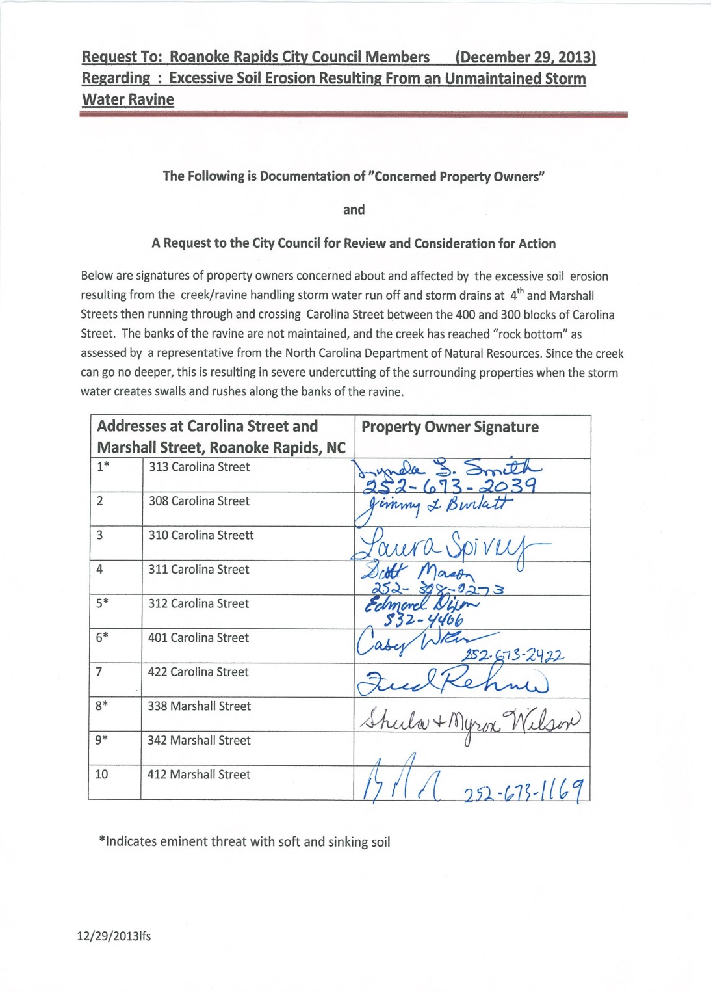

Ms. Smith also shared with Council a copy of the following maps:

17164
Roanoke Rapids City Council
January 7, 2014

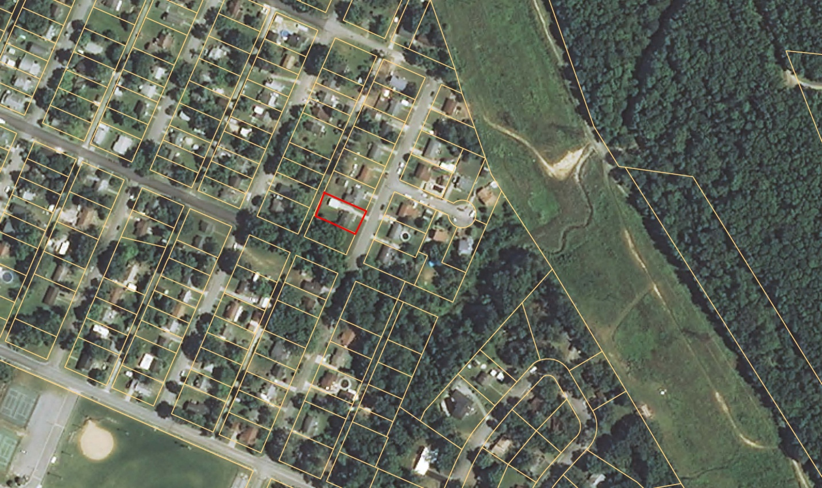

17165
Roanoke Rapids City Council
January 7, 2014

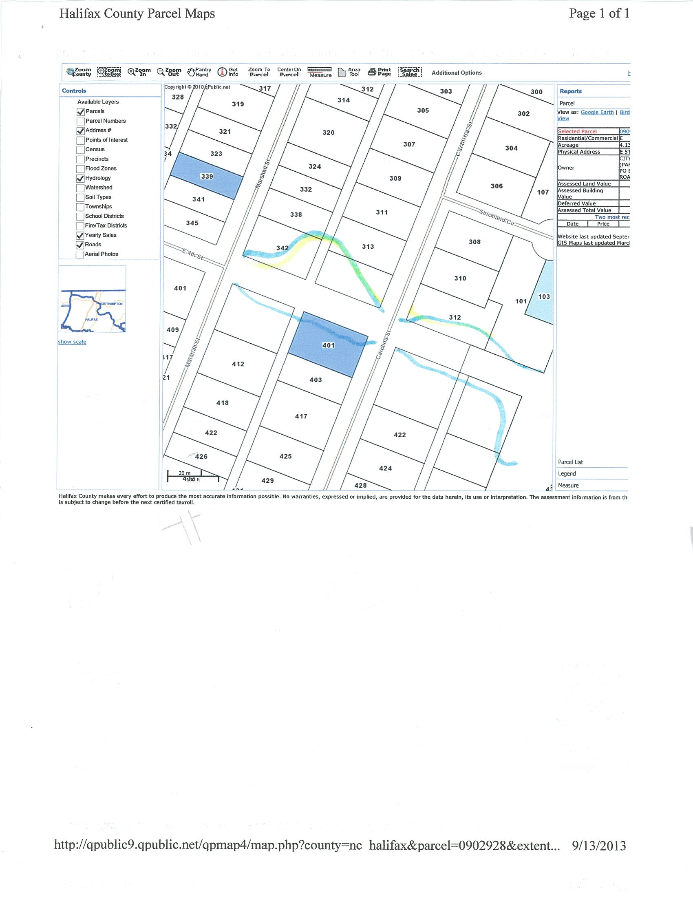

17166
Roanoke Rapids City Council
January 7, 2014

Ms. Smith stated she followed the chain of command and spoke with Public Works Director Chalker and City Manager Scherer, and several people with the State. She pointed out the following sequences of contacts and meetings regarding this matter:

Sequences of Contacts and Meetings Re: Erosion From Storm Water Ravine Between
Marshall and Carolina Streets (and Beyond)

August 9, 2013 | Contacted number on Emergency Contact Sign at storm drain. Sanitary District, David Scott came out within the hour, said not a Sanitary District issue, referred me to City Public Works, Mr. Larry Chalker.
August 12 -16, 2013 | Talked and met with Larry Chalker and Allen Mitchell from Public Works. They came to my property on Carolina Street; they made suggestions and said the City had no responsibility in reference to the erosion issue, that it was an erosion issue resulting from topsoil eroding from my land.
August 19-23, 2013 | Called several references from Larry Chalker:  Rightmyer came out within a week re: pilings, filling in the large ravine cliff area  at my property to stop wash away of soil.  John Pittman (landscaping) came out the following week and we discussed  possible solutions (dumping and filling in to build area where soil eroded).
September 18, 2013 | Met with City Manager, Mr. Joseph Scherer, who took my information and said he would check into it and get back with me.
October 3, 2013 | Mr. Dixon (owner of 312 Carolina Street) and I met with Mr. Will Mann, Fishing Creek Soil and Water Conservation District of Halifax County, at our properties on Carolina Street.
October 10, 2013 | Mr. Dixon and I met with Mr. Mann and Mr. Michael Young, Environmental Senior Technician from the North Carolina Department of Environment and Natural Resources (both expressed the issue was definitely caused by the undercutting of soil resulting from the storm water runoff from the storm drains into the ravine without appropriate reinforcement or erosion prevention measures along the cliffs of the ravine).
October 24, 2013 | Mr. Young sent email to Mr. Larry Chalker expressing concerns, with pictures and documentation regarding the infrastructure and erosion issues at both Carolina and Marshall Streets (where 4th Street dead ends at Marshall Street).
January 2, 2014 | Requested to be on the City Council Agenda to present request from 10 concerned and affected property owners (Carolina & Marshall Streets).

Ms. Smith pointed out that Mr. Edmond Dixon could not be here tonight but his wife Cheryl is present. She stated she does not have hundreds of thousands of dollars for pilings. She pointed out the following photo of her backyard showing the fence that she said will eventually fall into the ravine:

17167
Roanoke Rapids City Council
January 7, 2014

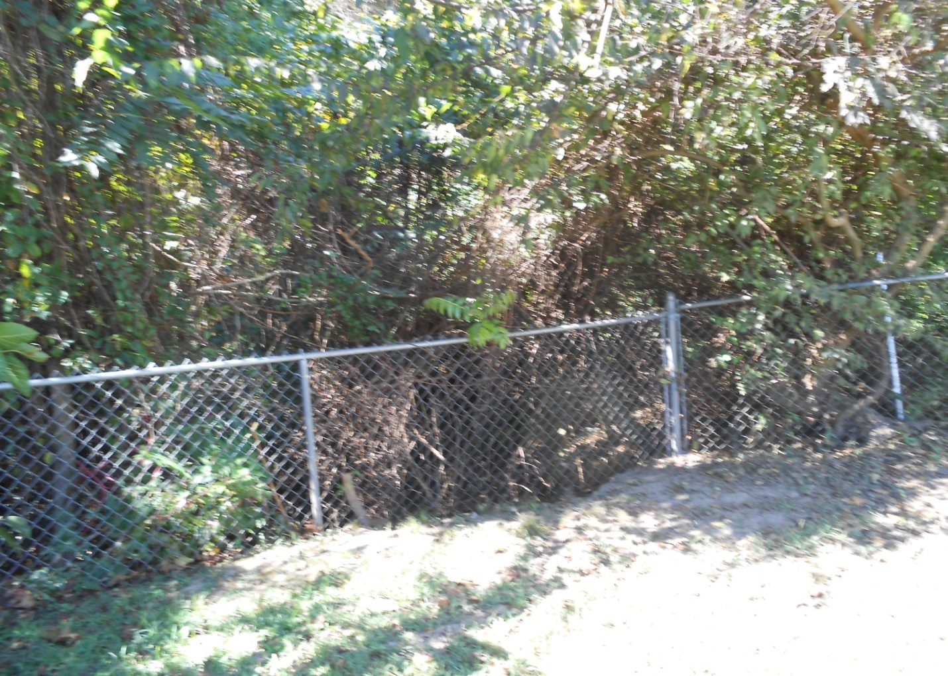

The remainder of the PowerPoint presentation is on file in the Clerk’s Office and copies have been provided to Council members.

Mayor Doughtie thanked Ms. Smith for her presentation and indicated that the City would try to give her some guidance on this.

Ms. Smith stated this is basically a big sink hole and some property owners may lose their homes.

Mr. David Harvey, President of the Halifax County Branch of the NAACP, invited Council to a wreath laying ceremony on Sunday, January 19 at 3:00 p.m. at the Martin Luther King, Jr. statue. He also requested that the City spruce up the property before the event.

17168
Roanoke Rapids City Council
January 7, 2014

Mr. Harvey also invited Council to attend the 2014 NAACP Emancipation Proclamation Banquet to be held on Friday, January 31 from 6:00 to 9:00 p.m. at the Mystique Multi Venue Complex located on Highway 125.

Motion was made by Councilman Bobbitt, seconded by Councilwoman Cowen and unanimously carried to approve the December 17, 2013 Council Minutes.

A ballot vote was taken and City Clerk Vincent announced that Dennis Gaylor received the unanimous vote for reappointment to the Firemen’s Relief Fund Board of Trustees.

Motion was made by Councilwoman Scarbrough, seconded by Mayor Pro Tem Ferebee and unanimously carried to reappoint Dennis Gaylor to the Firemen’s Relief Fund Board of Trustees.

City Manager Scherer reported that the Planning & Development Department is reviewing plans for the proposed relocation of Little Caesars next to PNC Bank in the Oakland Shopping Center. He pointed out that this location will have a drive-thru. He stated the department is also working with Petsense which hopes to open in the old Blockbuster building by the end of March.

City Manager Scherer reported that the Department of Environment and Natural Resources has inspected our leaf and debris sites, and all passed.

City Manager Scherer reported that we plan to have the presentation of the annual employee service awards at the February 4 Council meeting.

City Manager Scherer reported that we are moving forward with implementing increased security measures at City Hall which should be completed sometime next month.

17169
Roanoke Rapids City Council
January 7, 2014

City Manager Scherer reported that the AEDs (Automated External Defibrillators) have been installed in all City facilities and the Fire Department will be coordinating employee training.

City Manager Scherer reported that we have received five applications for the Main Street Manager position. He stated he will review the applications and coordinate with the RABA Board regarding interviews.

Mayor Pro Tem Ferebee asked who would be trained with the AEDs.

City Manager Scherer stated department heads, crew leaders and then everyone else in each facility.

There being no further business, motion was made by Mayor Pro Tem Ferebee, seconded by Councilwoman Scarbrough and unanimously carried to adjourn.

2/4/14

