Minute Book Page 18172

Minutes of the Roanoke Rapids City Council
A regular meeting of the City Council of the City of Roanoke Rapids was held on Tuesday, April 5, 2016 at 5:15 p.m. in the Council Chambers at the Lloyd Andrews City Meeting Hall.

Present: Emery G. Doughtie, Mayor
Carl Ferebee, Mayor Pro Tem
Ernest C. Bobbitt)
Council Members
Suetta S. Scarbrough)
Wayne Smith)
Carol H. Cowen)
Joseph Scherer, MPA, MS, City Manager
Gilbert Chichester, City Attorney
Lisa B. Vincent, MMC, NCCMC, City Clerk
Kathy Kearney, Deputy City Clerk/Human Resources Manager
Leigh Etheridge, Finance Director
Kelly Lasky, Planning & Development Director
Larry Chalker, Public Works Director
Stacy Coggins, Fire Chief
Chuck Hasty, Police Chief
Christina Caudle, Main Street Director
Kelly Manning, Assistant Parks & Recreation Director

Absent: John Simeon, Parks & Recreation Director

Mayor Doughtie called the meeting to order and opened the meeting with prayer.

Adoption of Business Agenda

Mayor Doughtie announced that Dr. Ketoff will be unable to attend this evening. He stated the agenda needs to be amended to remove Item 4 (a).

There being no conflict of interest with any of the items on the agenda, motion was made by Mayor Pro Tem Ferebee, seconded by Councilman Bobbitt and unanimously carried to adopt the business agenda for April 5, 2016 as amended to remove Item 4 (a).
Minute Book Page 18173

Special Recognitions

Police Department Recognitions
Police Chief Hasty recognized the following officers that recently graduated from the Coastal Plain Law Enforcement Management Institute at Wilson Community College: CID Captain Bobby Martin and Investigator Gorton Williams.

Police Chief Hasty also recognized the following officers for their actions in responding to an unusual call on February 22, 2016: Master Officer Gerald Morris, Officer Patrick Smith and Officer Ryan Cross. He presented them Commendation Award Certificates.

Approval of Council Minutes

Motion was made by Councilman Smith, seconded by Councilman Bobbitt and unanimously carried to approve the following Council Minutes: March 1, 2016 (Regular Meeting) and March 9, 2016 (Special Meeting—Council Retreat).

City Council Appointments

Reappointments to Canal Museum Advisory Committee
Motion was made by Councilwoman Scarbrough, seconded by Mayor Pro Tem Ferebee and unanimously carried to reappoint Christina Gregory to serve another three year term as the Arts Council Representative on the Canal Museum Advisory Committee.

A ballot vote was taken for the At-Large Member appointment and City Clerk Vincent announced that Dom Fenner received the unanimous vote for reappointment to the Canal Museum Advisory Committee.

Motion was made by Mayor Pro Tem Ferebee, seconded by Councilman Smith and unanimously carried to reappoint Dom Fenner to serve another three year term as an At-Large Member of the Canal Museum Advisory Committee.

Public Hearings

Rezoning Request from Mack Gay Associates, P.A. to Rezone Halifax County Tax Parcel 1205051 (10.04± Acres Adjacent to the Eastern Right-of-Way of NC Highway 125 and Adjacent to the North of Dickens Farm Road) from R-40 Residential to B-4 Commercial
Minute Book Page 18174

Planning & Development Director Lasky reviewed the following staff report with Council:

MEMORANDUM

TO: Joseph Scherer, City Manager

FROM: Kelly Lasky, Planning & Development Director/s/

RE: Rezoning Request (map attached) – Amendment to the Roanoke Rapids Zoning Map to Rezone Halifax County Parcel 1205051 (a 10.04± acre property) from R-40 Residential District to B-4 Commercial District (The property is adjacent to the eastern right-of-way of NC Highway 125 and adjacent to the north of Dickens Farm Road [private road])

DATE: March 21, 2016

Summary Overview

Subject Property |  | 10.04 +/- acres of property located along NC Hwy 125 with road frontage along NC 125 and Dickens Farm Rd (private)
Proposal |  | Rezone from R-40 Residential District to B-4 Commercial District
Applicant |  | Mack Gay Associates, P.A.
Property Owner |  | Roman Catholic Diocese of Raleigh
Present Use |  | Cleared, undeveloped land
Proposed Use |  | Ordinance Use 3.120: Office or clinic of physicians (Mid-Atlantic Eye Physicians)
Staff Recommendation |  | Approve  Figure 1 Aerial Image of Subject Property

when evaluating a rezoning request, it is appropriate to consider all permissible uses in the requested zoning district. city council cannot specifically limit which uses are allowed (or not) as a result of any rezoning consideration.

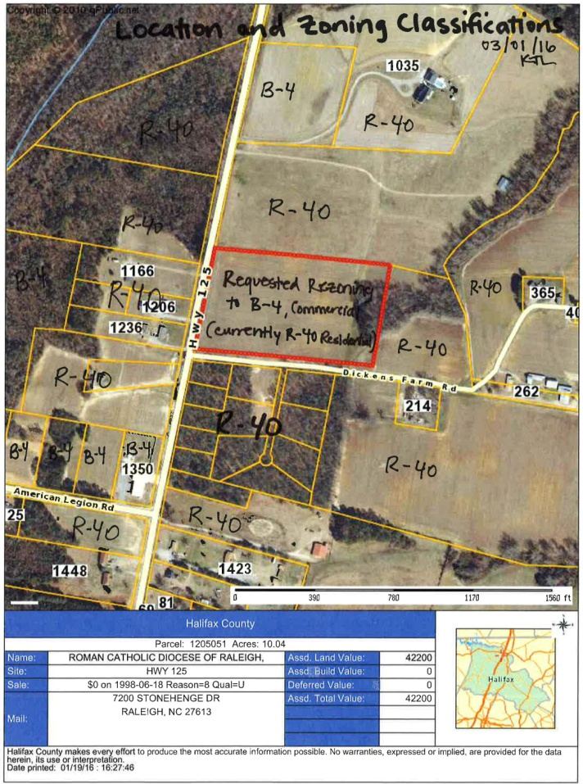
consider impacts on/from:
- potential uses
- neighbors
- general public
- traffic
- utilities
- neighborhood character
- schools

omit from consideration:
- ethnicity
- religion
- income
- rent or own
- ethnicity
- religion
- income
- rent or own

Minute Book Page 18175

Analysis and Detail:

1. Applicant and Property Owner

The applicant is Mack Gay Associates, P.A., 1667 Thomas A. Betts Pkwy., Rocky Mount, NC 27804; (252) 446-3017; contact: Scott Bumgarner. According to the application and Halifax County tax listing, the property owner is Roman Catholic Diocese of Raleigh, 7200 Stonehenge Dr., Raleigh, NC 27613. (Application for Rezoning and Supplemental Information Attached)
Figure 2 Roanoke Rapids Zoning Map Excerpt
2. Location/Area Description
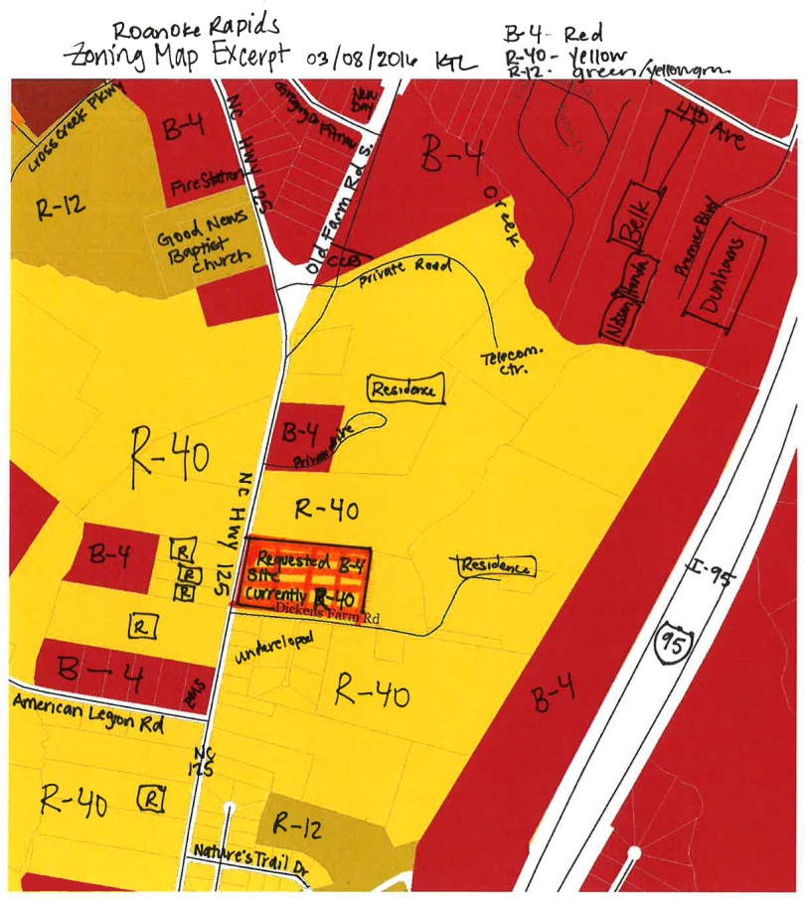
The site proposed for rezoning is located west of Interstate 95, along NC Hwy 125 in the City’s Planning & Zoning Jurisdiction, also known as the Extraterritorial Jurisdiction (ETJ). (See Figure 1, p 1) The site is approximately 1,000 feet to the south of the city limit boundary on NC Hwy 125 near Old Farm Road South and approximately 800 feet to the north of American Legion Road (State Road 1683).

The property requested for rezoning is 10.04± acres located adjacent to the eastern right-of-way of NC Hwy 125 having approximately 482.51 feet of road frontage and adjacent to the north of Dickens Farm Road (private road) having approximately 884.13 feet of road frontage. The property is undeveloped and used for small scale agricultural production.

The site area is a transition zone from rural residential and agricultural to more urbanized highway business.

3. Existing and Proposed Zoning

The Roanoke Rapids Zoning Map identifies the existing zoning classifications of the area being considered for rezoning and the nearby parcels. The requested rezoning area is currently zoned R-40 Residential District. The requested zoning is B-4 Commercial District. The subject rezoning site is surrounded by the R-40 Residential District and B-4 Commercial District properties are within close proximity along NC Hwy 125, Old Farm Road, and American Legion Road. (See Figure 2, p 2)

The rezoning request is a change from R-40 Residential District to B-4 Commercial District.

The uses allowed in each zoning district are identified in Section 151-149 Table of Permitted Uses of the City of Roanoke Rapids Land Use Ordinance. (Ordinance Excerpts Attached)

The following provides general descriptions of the existing and proposed zoning districts:

B-4: designed to accommodate the widest range of commercial activities with no minimum density (square footage) and a lot width of 70 feet. Setbacks from the street right-of-way property line are 20 feet and the distances from other property lines are determined by the rating
Minute Book Page 18176

of the exterior wall of construction

The commercial districts are created to accomplish the purposes and serve the objectives within each classification:

B-1: designed to accommodate a wide variety of commercial activities (particularly pedestrian oriented) that will result in most intensive and attractive uses of the city’s central business districts (Roanoke Avenue – Main Street class)

B-2: designed to accommodate a transition between B-1 and a residential zone or may provide for a smaller scale shopping center that primarily serves one neighborhood or area of the city (as opposed to a regional shopping center)

B-3: designed to accommodate a mixture of residential uses and uses that are primarily related to office, clerical, research and services, etc.). This district serves as a transition or buffer area between major roads and more intensively developed commercial areas and residential districts

B-4: designed to accommodate the widest range of commercial activities

B-5: designed to accommodate the offices and clinics of physicians and those uses customarily associated with hospital patients or visitors

The subject property is currently zoned R-40 Residential District:

R-40: intended to accommodate some types of uses that would be appropriate in more sparsely populated areas but would not be appropriate in more intensely developed residential zones. Single-family dwelling units and mobile homes used as single-family residences are permitted. The district is characterized for agricultural and woodland protection and production

Any proposed construction and site plans are evaluated by city staff and the Development Review Committee to ensure a proper design. The Development Review Committee includes the Sanitary District, NCDOT, Public Works, NC Dominion Power, Fire Department and Code Enforcement.

4. Traffic Considerations

All traffic considerations will be evaluated when the proposed use and a preliminary site development plan are officially submitted for review by a future developer. The North Carolina Department of Transportation (NCDOT) regulates placement of access and driveway permitting for properties on state roads. NCDOT Highway Division 4, District 1 District Engineer would be responsible for granting NC Hwy 125 access to the subject site. Preliminary comments from District Engineer Ronald Keeter were received 03-04-2016 in response to a request for comment concerning the requested rezoning: Access would be granted to this property. It is a good size lot. If there were multiple businesses on the parcel, NCDOT would require access to be provided through one single driveway located as far away from American Legion Road as possible. There may be required roadway improvements to be done by the development/developer. There is an existing TIP project for NC 125 to be widened to a multi-lane section along this property. You may want to note future improvements in your staff report.

If the request for rezoning is approved, the Applicant has stated that the intended use of the property is a physician’s clinic. According to the Institute of Transportation Engineers, Trip Generation Manual, 7th Edition, the standard trip generation rates for “Medical Office Building” land use are provided including estimates of vehicles added to NC Hwy 125.

Land Use | Units | AM Peak Hour | PM Peak Hour | Daily Rate
Medical Office Building | Units = (Building SF/ 1,000 SF) | 2.48 (#units) | 3.72 (#units) | 36.13 (#units)
Proposed Eye Care Center | 12.35 units = (12,350/1,000) | 30.63 trips AM Peak Hr = (2.48)(12.35) | 45.94 trips PM Peak Hr = (3.72)(12.35) | 446.21 trips per day = (36.13)(12.35)
Minute Book Page 18177

5. Utility Considerations

There are no specific utility considerations that should negatively impact this property at the present time. The area is served by Roanoke Electric and the Roanoke Rapids Sanitary District. Halifax County has a water line in front of this parcel but it is a dead end line. The Developer will need to determine if it has adequate flow, pressure and quality to support the proposed development. Sewer line extensions will need to be determined by the Developer. All connections, extensions and responsibilities for services will be the responsibility of the developer.

6. Other Considerations

Future development of the site will be evaluated for appropriate screening, drainage, stormwater retention/detention and other items during the site plan and/or construction plan review process by the Development Review Committee. Opaque screening between potential commercial uses and existing residential uses will be required at the burden of the commercial developer. The ordinance requires opaque screening from the ground to a height of at least eight feet, which may be a wall, fence, landscaped earth berm, planted vegetation or existing vegetation.

The subject property is located in the District of the Rheasville Volunteer Fire Department, the primary responding agency for the site. Per request, the City of Roanoke Rapids Fire Department may respond for mutual aid. Future development of the site will be evaluated for adequate water supply for firefighting operations and that driveways meet the requirements for apparatus ingress/egress.

7. Comprehensive Development Plan

The property is located outside City Limits and within the Planning & Zoning Jurisdiction. The following implementing strategies may be considered from the City of Roanoke Rapids Comprehensive Plan, adopted by City Council on June 17, 2014:

I.1 Support infill development. Infill development is development or redevelopment of land that has been bypassed, remained vacant, undervalued and/or is underused as a result of the continuing urban development process. Generally, the areas and/or sites are not particularly of prime quality; however, they are usually served by or are readily accessible to the infrastructure (services and facilities). Use of such lands for new housing and/or other urban development is considered a more desirable alternative than to continue to extend the outer development pattern. The use of infill development, among others, promotes the best use of resources and also will tend to have a positive impact upon the tax and other fiscal policies.

I.7 Provide effective buffering and/or landscaping where commercial development adjoins existing or planned residential uses.

I.10 Encourage office and institutional development to located as a transitional land use between activities of higher intensity and those of lower intensity.

I.18 Utilize the mixed use areas as a tool to aid in regulating/reducing strip commercialization, stimulate compact development, encourage infill development, reduce trip generation, provide flexible development options, and utilize existing infrastructure.

I.20 Encourage developers to utilize thoroughfares and natural topographic features to define the boundaries of a neighborhood and concentrate higher intensity uses at the outer boundaries of the neighborhood.

I.32 Protect, enhance, and encourage a high quality of life, image, and cultural amenities as an effective approach to economic development.

I.33 Economic development efforts should encourage the revitalization and reuse of currently unused or underutilized structures, sites, and infrastructure in appropriately located areas.

Minute Book Page 18178

8. Public Response to Notice

Letters were sent to owners of property within 100feet of the requested rezoning on March 21, 2016. The notice of request and City Council’s Public Hearing was advertised in the Daily Herald on March 20, March 27, and April 3, 2016.

The Applicant (Mack Gay Associates, Inc.) notified the property owners of a community open house meeting, scheduled in the first floor conference room of the J. Reuben Daniel City Hall, located at 1040 Roanoke Avenue on March 14, 2016 from 4:30 – 6:00 p.m. The purpose of the meeting was to provide plans for the property if the rezoning request is approved. (Community Meeting Letter and Site Plan - Attached)

9. Staff Recommendation

The proposed request for rezoning is considered to be reasonable. Reasonableness is determined by considering the size and nature of the tract, any special conditions or factors regarding the area, the consistency of the zoning with the land use plan, the degree of the change in the zoning, the degree it allows uses different from the surrounding area, and the relative benefits and/or detriments for the owner, the neighbors, and the surrounding community.

The Planning and Development Staff recommends in favor of the petitioner’s request. The staff finds the proposed rezoning request to be consistent with the area land uses and supported by the Comprehensive Development Plan. Staff requests that the rezoning be recommended to the City Council for approval.

The courts have established the following factors to determine the reasonableness of spot zoning:

- The size and nature of the tract. Planning Staff has determined that the size and characteristics of the site make it more likely to be reasonable to zone. The site is a large parcel having significant street frontage along a state road providing access to Interstate 95. The site has access to utilities and a relatively flat topography.
- Compatibility with existing plans. The Land Use Ordinance sets forth the requirements for the various zoning districts. The Comprehensive Plan adopted by the City Council June 17, 2014 proposes and supports mixed uses in the subject area. Buffering or separation between uses is encouraged to minimize impact and provide a transition between lower and higher density land uses.
- The impact of the zoning decision on the landowner, the immediate neighbors, and the surrounding community. The degree of change from R-40 to B-4 represents an increase in potential land use intensities as well as a few similarities in existing permissible uses. The specific potential benefits to the owner and the specific potential impacts to the neighbors are unknown at this time. However, evaluation of the site access, surrounding rural uses, nearby commercially zoned property, and sparse population makes the proposed request more reasonable.
- The relationship between the newly allowed uses in a spot rezoning and the previously allowed uses. Planning Staff has evaluated and compared the permitted uses in the B-4 and R-40 Districts. The Table of Permissible Uses (Section 141-49) includes all permissible uses for all zoning districts. Therefore, Staff has determined that the relationships between the uses in the current zoning classification and the uses in the proposed classification support the reasonableness of the petitioner’s request.
10. Planning Board Recommendation

The Roanoke Rapids Area Planning Board reviewed the requested rezoning on March 17, 2016. The Board unanimously approved the Recommendation of Consistency with a 7-0 vote. After a presentation from the applicant and receiving comments from the affected property owners, the Board unanimously voted 6-0 to forward a favorable recommendation to City Council for consideration of approval of the rezoning as a B-3 Commercial District, which permits churches and medical offices.
Minute Book Page 18179

11. City Council Action

Following the public hearing, the City Council is requested to make a motion concerning the Statement of Consistency and a motion concerning approval or denial of the rezoning request.

Statement of Consistency – if City Council concurs with the approval of the Statement, the following motion is appropriate.

Requested Motion & Vote: Motion to approve and adopt the presented Statement of Consistency to amend the Zoning Map to a commercial district for Halifax Co. Parcel 1205051, described in the staff report dated March 21, 2016.

Final Decision – if City Council concurs with approval of the rezoning request, the following motion is appropriate.

B-4 Approval (as submitted):
Requested Motion & Vote: Motion to approve an amendment to the Roanoke Rapids Zoning Map to change the zoning classification to B-4 Commercial District for 10 acres of property located at NC Hwy 125 and Dickens Farm Road (Halifax Co. Parcel 1205051) and described in the staff report dated March 21, 2016.

OPTION: B-3 Approval (as Recommended by Planning Board):
Requested Motion & Vote: In consideration of the Planning Board’s recommendation, comments from the community, and the Applicant’s intended use of the property, a Motion to approve an amendment to the Roanoke Rapids Zoning Map to change the zoning classification to B-3 Commercial District for 10 acres of property located at NC Hwy 125 and Dickens Farm Road and described in the staff report dated March 21, 2016.

Attachments
- Application for Rezoning and Supplemental Information
- Excerpts of the Roanoke Rapids Land Use Ordinance, Table of Permissible Uses
- Community Meeting Letter and Site Plans
- Statement of Consistency

[Note: All attachments referred to in the foregoing staff report are on file
in the Clerk’s Office and hereby incorporated by reference.]

The following letter was received by the City Clerk on March 30, 2016 in compliance with the public notice:

March 28, 2016

City of Roanoke Rapids
Attn. Lisa Vincent
P O Box 38
Roanoke Rapids NC 27870
Minute Book Page 18180

Dear City Council Members:

I am the property owner joining on the South and the East backside of the Catholic property. My home farm of 100 acres is registered in NC Century Farms currently 115 years. Also, it is recorded in Halifax County Agricultural District. The purpose of this is to inform adjoining landowners and the public of a farming operation which consist of blowing dust, chemical odors, equipment noise, movement of grain wagons, 18 wheeler trucks, cotton module trucks. This is activity of a 600 acre farming operation.

Would a place of business want to contend with this next door?

The request letter stated small scale agricultural production. There is also 160 acres or more in crop production within sight of this property. There is NO small scale agriculture operation in the area.

I have been farming the Catholic land for 14 years. I have had very good dealings with them.

There is approximately 7 tenths classed as wetlands property, there are 2 natural run drain ditches that flow on the east side of this property, there is no sewage hookup.

My farming operation would have to contend with wrong entrance turns onto Dickens Farm Road and adjoining residences would have to hear blowing horns, parking lot lights would be like a football stadium. The additional traffic created on 125 would be a big traffic jam.

The location is not suitable for this request when just to the north at Gregory Lane there are lots ready for construction.

Please consider this information when making your decision on this request.

Sincerely,

Edward Lee Dickens/s/
365 Dickens Farm Road
Roanoke Rapids NC 27870

A public hearing having been advertised and proper notices having been given according to law, Mayor Doughtie opened the public hearing for comments.

Dr. Brian Crichlow of Mid-Atlantic Eye Physicians, 204 Becker Drive, Roanoke Rapids, NC thanked the Council for taking time to consider his request. He stated he has been practicing ophthalmology in Roanoke Rapids since 2004 and has recognized a tremendous need for certain types of eye care here. He stated he would like to be able to expand to offer more services such as retinal surgical care. Dr. Crichlow stated they also want to expand for the safety of their patients. He stated at the current site, they have limited parking and sometimes patients have to park across a busy street. He also stated that by expanding, they are providing additional employment opportunities for people in the area.

Minute Book Page 18181

There being no one else to speak, Mayor Doughtie declared the public hearing closed.

Motion was made by Mayor Pro Tem Ferebee, seconded by Councilwoman Scarbrough and unanimously carried to approve and adopt the following Statement of Consistency to amend the Zoning Map to a commercial district for Halifax Co. Parcel 1205051 described in the foregoing staff report dated March 21, 2016:

Statement of Consistency with Plans to Amend the Official Zoning Map

Request– Amendment to the Roanoke Rapids Zoning Map to rezone Halifax Co. Parcel 1205051 (a 10.04± acre property) from R-40 Residential District to a B-3 Commercial District. The property is adjacent to the eastern right-of-way of NC Highway 125 and adjacent to the north of Dickens Farm Road (private road).

The Roanoke Rapids City Council met on Tuesday, April 6, 2016 at 5:30 p.m. and determined that the above mentioned request is consistent with the Roanoke Rapids Comprehensive Plan, adopted by City Council June 17, 2014, and with the Roanoke Rapids Land Use Ordinance. Comprehensive Development Plan Policies:

I.1 Support infill development. Infill development is development or redevelopment of land that has been bypassed, remained vacant, undervalued and/or is underused as a result of the continuing urban development process. Generally, the areas and/or sites are not particularly of prime quality; however, they are usually served by or are readily accessible to the infrastructure (services and facilities). Use of such lands for new housing and/or other urban development is considered a more desirable alternative than to continue to extend the outer development pattern. The use of infill development, among others, promotes the best use of resources and also will tend to have a positive impact upon the tax and other fiscal policies.

I.7 Provide effective buffering and/or landscaping where commercial development adjoins existing or planned residential uses.

I.10 Encourage office and institutional development to located as a transitional land use between activities of higher intensity and those of lower intensity.

I.18 Utilize the mixed use areas as a tool to aid in regulating/reducing strip commercialization, stimulate compact development, encourage infill development, reduce trip generation, provide flexible development options, and utilize existing infrastructure.

I.20 Encourage developers to utilize thoroughfares and natural topographic features to define the boundaries of a neighborhood and concentrate higher intensity uses at the outer boundaries of the neighborhood.

I.32 Protect, enhance, and encourage a high quality of life, image, and cultural amenities as an effective approach to economic development.

I.33 Economic development efforts should encourage the revitalization and reuse of currently unused or underutilized structures, sites, and infrastructure in appropriately located areas.

Upon review of the request, it is the City Council’s determination that the above mentioned request is reasonable and in the public interest of the City of Roanoke Rapids in that it provides for the organized commercial and industrial growth that will help to ensure the health, safety, and general welfare of the citizens of Roanoke Rapids.

ADOPTED BY THE ROANOKE RAPIDS CITY COUNCIL ON THE 5TH DAY OF APRIL 2016.

Emery G. Doughtie, Mayor
Minute Book Page 18182

Mayor Pro Tem Ferebee stated in consideration of the Planning Board’s recommendation, comments from the community, and the applicant’s intended use of the property, he moves to approve an amendment to the Roanoke Rapids Zoning Map to change the zoning classification to B-3 Commercial District for 10 acres of property located at NC Highway 125 and Dickens Farm Road as described in the foregoing staff report dated March 21, 2016. Councilwoman Scarbrough seconded the motion.

Councilman Smith asked if the applicant is okay with B-3.

Planning & Development Director Lasky stated there has been no objection raised to rezoning the property to B-3. She pointed out that should the sale of the property fall through, the Catholic Church could still have a church in the B-3 Commercial District.

Upon being put to a vote, the motion on the floor carried unanimously.

New Business

Consideration of Contract with Gregory T. Redman, CPA to Conduct Annual Audit
Finance Director Etheridge stated in accordance with NCGS 159-34(a), City Council must approve a contract for the audit of the City’s financial statements. She stated Council has been provided copies of the Engagement Letter and Contract with Gregory T. Redman, CPA to conduct the audit of the City’s financial statements for 2016 for $19,900.00. Finance Director Etheridge pointed out that there is no change in the cost from last year.

Motion was made by Councilman Bobbitt, seconded by Councilwoman Cowen and unanimously carried to approve the Letter of Engagement and Contract with Gregory T. Redman, CPA, dated February 19, 2016, to conduct the audit of the City’s financial statements for 2016 for $19,900.00, and to authorize the Mayor to execute the Engagement Letter and Contract. [Copies of the Letter of Engagement and Contract are on file in the Clerk’s Office and hereby incorporated by reference.]

City Manager’s Report

City Manager Scherer reported that we are holding discussions later this week with the Local Government Commission (LGC) to review a refinancing proposal of theirs for Bank of America (BOA) as well as discussing the coordination of arranging a meeting with BOA officials. He stated we have had an initial discussion with someone possibly interested in purchasing the Theater, but nothing new to report.

Minute Book Page 18183

City Manager Scherer reported that the Fire Department has advised that work on the gazebo in Centennial Park is complete except for a few touchups. He stated the department is also beginning work on cleaning up Veterans Park. He stated Chief Coggins and two other department members attended a Fire Prevention school, and also the Fire Department hosted the County Fire Association meeting last month. He stated Chief Coggins also coordinated a multi-county training drill held yesterday evening at the old police station on Roanoke Avenue.

City Manager Scherer reported that Human Resources Manager Kearney has advised that BARC is holding a luncheon fundraiser fish fry at Pro-Build on Friday, April 29th beginning at 11:30 a.m. He pointed out that one of the things this will help fund is their Scholarship Program for full-time employees’ children, which will be given out later this spring.

City Manager Scherer reported that the Parks & Recreation Department has indicated that the Tourism Board will hold a grand opening for their bike lender program on Saturday, April 16th at Riverside Mill beginning at 10:00 a.m. He stated the department also indicated that Kirkwood Adams Community Center is booked for rentals almost every weekend from now until October. He stated the department has been advised that the AMVETS are holding the Memorial Day ceremony at Cederwood Cemetery on Monday, May 30th at 10:00 a.m.

City Manager Scherer reported that the Planning & Development Department indicates that they continue to work on reviewing the site plans for the new State Employees Credit Union building and the building plans for the new Manning Elementary School. He stated they also have received a rezoning proposal from MaSuKi, Inc. for their Cross Creek site, so a joint Planning Board/City Council meeting is planned for Thursday, April 21st at 5:30 p.m. here in Council chambers. He stated the intent is to hold the required public hearing for the request then instead of at the May 3rd Council meeting.

City Manager Scherer reported that the Roanoke Rapids Main Street group is holding their Arts on the Avenue Festival this Thursday, April 7th from 5:00-8:00 p.m. He stated more than a dozen stores will be open with more than 20 artisans and musicians on hand. He stated also, several available properties will be open for viewing by potential investors or entrepreneurs.

City Manager Scherer reported that the Police Department has advised that one suspect was arrested in the home invasion last week on Marshall Street and one other suspect is being sought. He stated Chief Hasty reported that everyone had a good time at the Womanless Beauty Pageant last week and raised a lot of funds for the Relay for Life

Minute Book Page 18184

program. He stated the Police Department will be helping with the Manning School Color Run this Saturday and with the HCC Safe Kid program on Saturday.

Councilman Smith stated as a member of the Board for the Roanoke Valley Youth Baseball Association, he would like to thank all those involved in getting the fields at Ledgerwood and Doyle Field ready for the big Little League baseball tournament to be held here in July. He thanked the City Manager, the Planning & Development Department, the Fire Department, the Public Works Department and the Parks & Recreation Department for what they have done for our Little League Association.

There being no further business, motion was made by Mayor Pro Tem Ferebee, seconded by Councilwoman Scarbrough and unanimously carried to adjourn.

Lisa B. Vincent, MMC, NCCMC City Clerk

5/3/2016
Approved by Council Action on:

