Minute Book Page 18086

Minutes of the Roanoke Rapids City Council
A regular meeting of the City Council of the City of Roanoke Rapids was held on Tuesday, February 2, 2016 at 5:15 p.m. in the Council Chambers at the Lloyd Andrews City Meeting Hall.

Present: Carl Ferebee, Mayor Pro Tem
Ernest C. Bobbitt)
Suetta S. Scarbrough)
Council Members
Carol H. Cowen)
Wayne Smith)
Joseph Scherer, MPA, MS, City Manager
Gilbert Chichester, City Attorney
Lisa B. Vincent, MMC, NCCMC, City Clerk
Kathy Kearney, Deputy City Clerk/Human Resources Manager
Leigh Etheridge, Finance Director
Larry Chalker, Public Works Director
John Simeon, Parks & Recreation Director
Kelly Lasky, Planning & Development Director
Stacy Coggins, Fire Chief
Chuck Hasty, Police Chief
Christina Caudle, Main Street Director

Absent: Emery G. Doughtie, Mayor

Mayor Pro Tem Ferebee called the meeting to order and opened the meeting with prayer.

Adoption of Business Agenda

There being no conflict of interest with any of the items on the agenda, motion was made by Councilman Smith, seconded by Councilman Bobbitt and unanimously carried to adopt the business agenda for February 2, 2016 as presented.

Special Recognitions

Presentation of Employee Service Awards
Prior to the meeting, members of BARC (Benevolent, Awards & Recognition Committee) held a reception for employees receiving Service Anniversary Awards.

The following employees received service anniversary award certificates and lapel pins from their respective department heads:

Minute Book Page 18087

Name | Department | Years of Service
Scott Blythe | Police | 5
Christopher Neal Campbell | Public Works | 5
Jeremy Gordon | Public Works | 5
Rose Massey | Parks & Recreation | 5
Jerell Evans | Public Works | 10
Charles Burnette, Jr. | Police | 15
William I. Harris, Jr. | Fire | 15
Edward A. Jackson | Police | 15
Lakeshia Jones | Public Works | 15
Kelly D. Manning | Parks & Recreation | 15
Mark Peck | Police | 15
Gary A. Faulcon | Parks & Recreation | 20
John Simeon | Parks & Recreation | 20
Bruce Norton | Police | 20
Douglas Love | Public Works | 20
Marvin Purnell | Public Works | 25
Michael Clements | Fire | 25
Timothy Gray | Fire | 25
Lisa B. Vincent | Administrative | 30

City Manager Scherer recognized Human Resources Manager Kearney and the members of BARC for hosting the reception.

Recognition of Recent Police Department Promotion
Police Chief Hasty recognized the promotion of Adam Salmon from Police Officer II to Master Police Officer. He indicated that Adam has been in law enforcement for 14 years and has been with the Roanoke Rapids Police Department since 2012.

Proclamation for National Canned Food Month
Mayor Pro Tem Ferebee read the following Proclamation signed by Mayor Doughtie:

FEBRUARY - NATIONAL CANNED FOOD MONTH

WHEREAS, according to the Feeding America organization, although related, food insecurity and poverty are not the same. Poverty is only one of many factors associated with food insecurity. In fact, higher unemployment, lower household assets, and certain demographic characteristics also lead to a lack of access to adequate, nutritious food; and

WHEREAS, in 2013, an estimated 45.3 million people were in poverty and 49.1 million Americans lived in food insecure households, including 33.3 million adults and 15.8 million children; and

WHEREAS, the Angel’s Closet Ministry is helping to provide food, as well as other items, to needy families year-round; and

WHEREAS, February is National Canned Food Month which promotes the nutritious benefits, convenience and long shelf life of canned foods; and

WHEREAS, the City of Roanoke Rapids is proud to sponsor a canned food drive during the month of February to assist Angel’s Closet with feeding those in need;

NOW, THEREFORE, I, EMERY G. DOUGHTIE, by virtue of the authority vested in me as Mayor of the City of Roanoke Rapids do hereby proclaim February as “National Canned Food Month” in the City of
Minute Book Page 18088

Roanoke Rapids and encourage all residents to donate canned food items during the month of February to support the efforts of the Angel’s Closet Ministry to feed the hungry. Canned food items can be dropped off at the following collection sites: City Hall/Police Department; Fire Stations 1 & 2; T. J. Davis Recreation Center; Chaloner Recreation Center and Public Works Department. Residents can also place a bag of canned food items next to their front door for collection by 8:00 a.m. each Friday during the month of February.

PROCLAIMED this 29th day of January, 2016.

Emery G. Doughtie, Mayor

Approval of Council Minutes

Motion was made by Councilman Bobbitt, seconded by Councilwoman Cowen and unanimously carried to approve the January 19, 2016 Council Minutes.

City Council Appointments/Reappointments

Appointment to Senior Center Advisory Committee
A ballot vote was taken and City Clerk Vincent announced that Ann Gibbs received the unanimous vote for appointment to the Senior Center Advisory Committee.

Motion was made by Councilwoman Cowen, seconded by Councilman Bobbitt and unanimously carried to appoint Ann Gibbs to the Senior Center Advisory Committee.

Appointment of Roanoke Rapids Graded School District Representative to Recreation Advisory Committee
Motion was made by Councilwoman Cowen, seconded by Councilman Bobbitt and unanimously carried to appoint Eric Daniels to serve as the Roanoke Rapids Graded School District Representative on the Recreation Advisory Committee.

Public Hearings

Consideration of Rezoning Request from Gil Cunningham to Rezone Approximately 83 Acres at 395 Wallace Fork Road from B-4 Commercial-Entertainment Overlay District to I-2 Industrial District [Continued from January 5 & 19, 2016 Council Meetings]
Planning & Development Director Lasky highlighted the following staff report which was first presented to Council at the January 5 meeting and again at the January 19 meeting:

MEMORANDUM

To: Joseph Scherer, City Manager

From: Kelly Lasky, Planning & Development Director/s/

Re: Rezoning Request (map attached) – Amendment to the Roanoke Rapids Zoning Map to Rezone 83.3+/- Acres of Property at 395 Wallace Fork Road from B-4 Commercial District-Entertainment Overlay District to I-2 Industrial District
Minute Book Page 18089

Date: December 28, 2015

Summary Overview
Subject Property |  | 83.3+/- acres of property located at 395 Wallace Fork Road with road frontage along Wallace Fork Road and Aurelian Springs Road
Proposal |  | Rezone from B-4 Commercial District with Entertainment Overlay District to I-2 Heavy Industrial District
Applicant |  | Gil Cunningham
Property Owner |  | Carolina Dirt, LLC
Present Use |  | Cleared, undeveloped land, previously utilized as an outdoor concert venue
Proposed Use |  | Not stated in application
Staff Recommendation |  | Approve

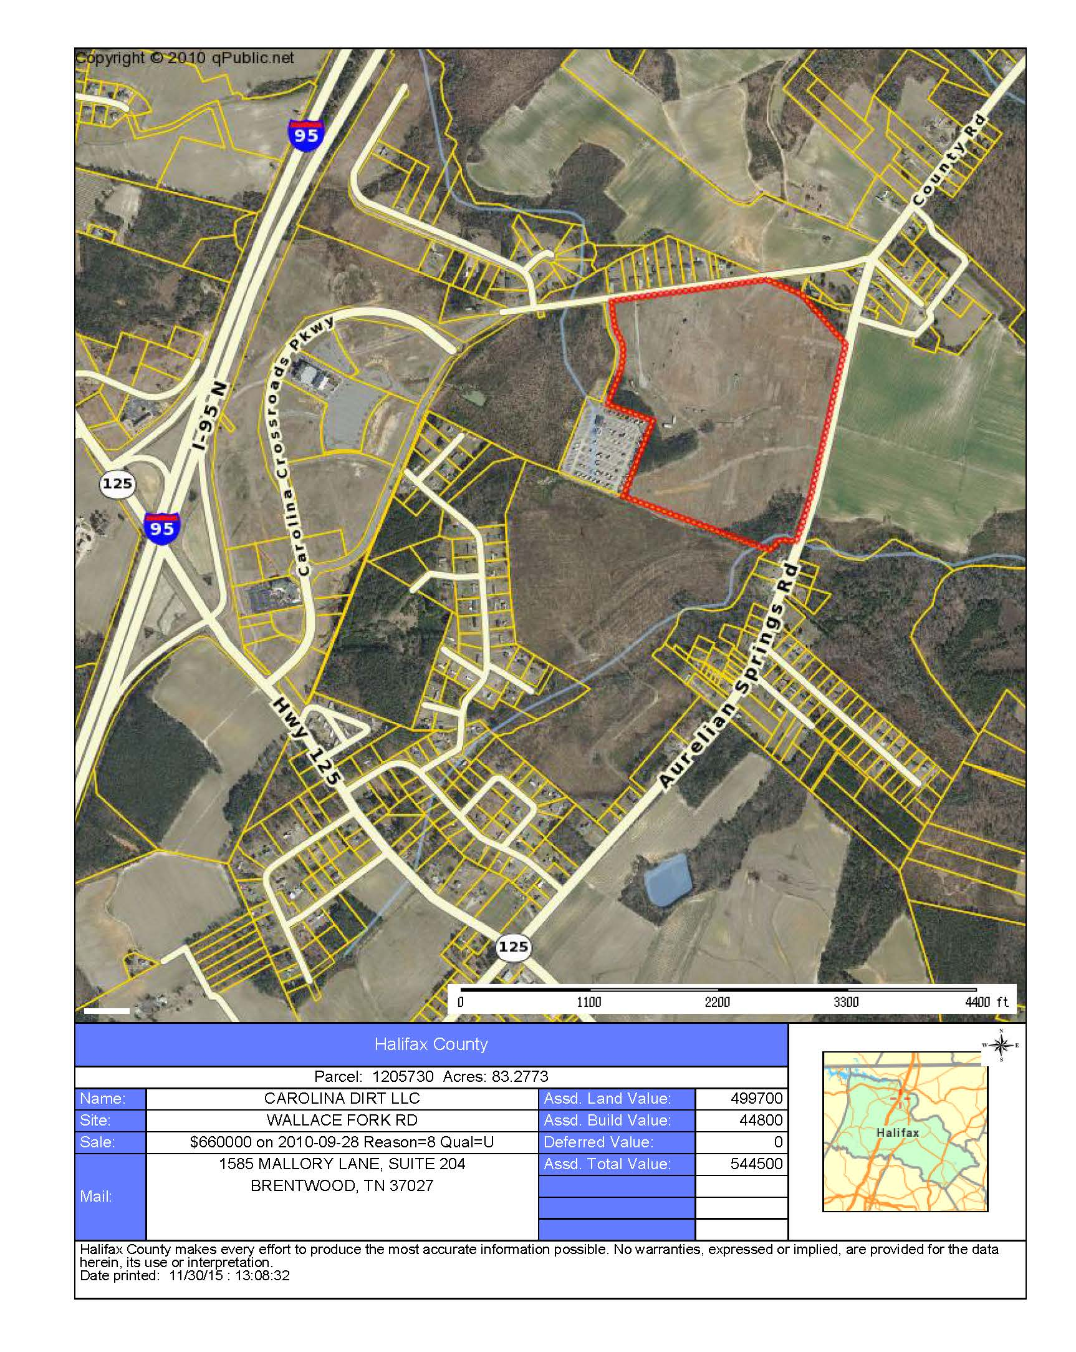
When evaluating a rezoning request, it is appropriate to consider ALL permissible uses in the requested zoning district. City Council cannot specifically limit which uses are allowed (or not) as a result of any rezoning consideration.

Consider impacts on/from:
- potential uses
- neighbors
- general public
- traffic
- utilities
- neighborhood character
- schools

Omit from Consideration:
- ethnicity
- religion
- income
- rent or own

Analysis and Detail:

1. Applicant and Property Owner
The applicant is Gil Cunningham, 1243 Monarch Way, Brentwood, TN 37027; (615) 497-3822. According to the Halifax County tax listing, the property owner is Carolina Dirt, LLC, 1585 Mallory Lane, Suite 204, Brentwood, TN 37027.

2. Location/Area Description
The site proposed for rezoning is located east of Interstate 95 in the area referred to as “Carolina Crossroads” Music and Entertainment District. In the year 2006, the site was originally part of the establishment of the Roanoke Rapids Entertainment, LLC subdivision and sold to Carolina Dirt, LLC in September 2010. The Entertainment District is popularly known for the developments of the Hilton Garden Inn, the Roanoke Rapids Theater, and the Carolina Crossroads (RV) Recreational Vehicle Park.
The location of the site proposed for rezoning is addressed 395 Wallace Fork Road. The 83.3+/- acre site has approximately 1,372 feet of street frontage along Wallace Fork Road (SR 1692) and 1,800 feet of street frontage along Aurelian Springs Road (SR 1600). The site is currently zoned B-4 Commercial District with Entertainment Overlay District (EOD) jurisdiction.

Minute Book Page 18090

The area to the southeast of the site proposed for rezoning has an R-20 Residential zoning classification and is developed as single-family residential use.

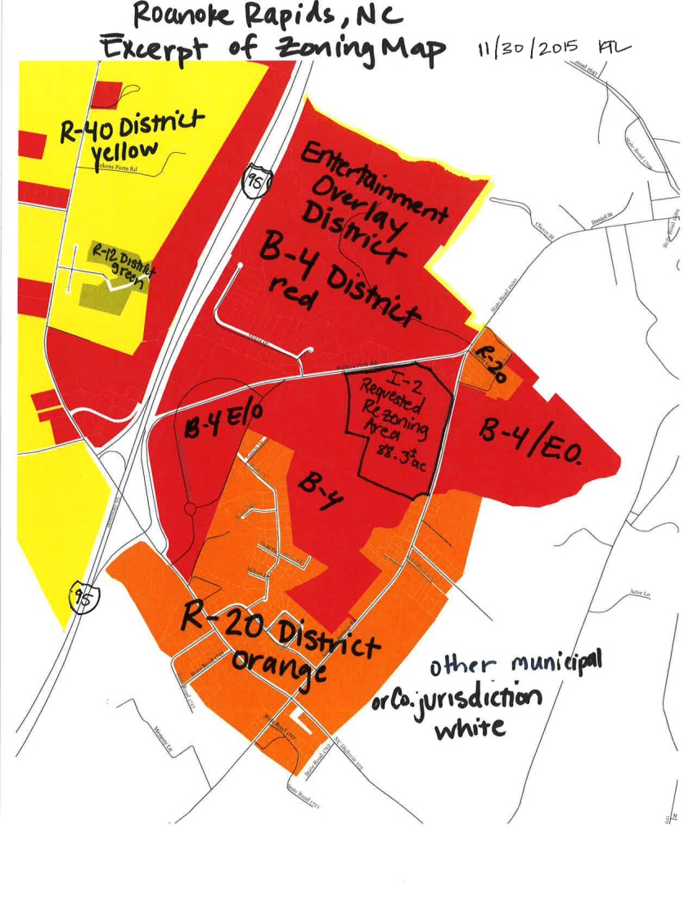
The adjacent areas to the east, north, south and west of the site proposed for rezoning are commercially zoned B-4 with EOD. The rezoning site is located adjacent (east of) the Carolina Crossroads RV Park (a conforming use in the EOD District).

There are nine (9) properties along Wallace Fork Road (north of the subject site) that are developed as single-family residential mobile homes. There is one property to the northeast of the site along Aurelian Springs Road that is developed as a single-family residential, conventional home. The residential use of these properties is designated as a grandfathered, legal, non-conforming use of the land in the B-4 EOD District. The single-family residential use of these properties was made unlawful by the Land Use Ordinance use regulations when the B-4 Commercial District was established in the area. Since the residential use was lawful prior to the establishment of the current zoning classifications, the non-conforming residential use of the properties may continue subject to Article VIII of the Ordinance.

The property to the east and south of the site proposed for rezoning is generally characterized as undeveloped, rural, agricultural use.

3. Existing and Proposed Zoning
The excerpt of the zoning map (item 2, page 2) delineates the existing zoning of the area being considered for rezoning and the zoning of the adjacent parcels. The requested rezoning area is currently zoned B-4 Commercial District with Entertainment Overlay District (EOD) jurisdiction. The requested zoning is I-2 (Heavy) Industrial District. The subject rezoning site is predominantly surrounded by the B-4 Commercial District with Entertainment Overlay District and has a minor adjacent area zoned R-20 Residential District.

The rezoning request is a change from B-4 Commercial District with EOD to I-2 (Heavy) Industrial District.
The following provides general descriptions of the existing and proposed zoning districts:

The R-20 district is designed to accommodate single-family dwelling units. Lots in the R-20 district are required to have a minimum density of 20,000 square feet, 100 feet in width and building setbacks of 30 feet from the street right-of-way property line and 10 feet from all other property lines.

The B-4 district is designed to accommodate the widest range of commercial activities with no minimum density (square footage) and a lot width of 70 feet. Setbacks from the street right-of-way property line are 20 feet and the distances from other property lines are determined by the rating of the exterior wall of construction.

The Entertainment Overlay District (EOD) is located over all B-4 commercial district properties in the designated Carolina Crossroads area. The density and dimensional requirements of the B-4 district are
applicable in the EOD. The EOD is unique in that it allows only uses permitted in the Table of Permissible Uses in the Entertainment Overlay District (Land Use Ordinance Article XXIV, Section 151-363).

The uses allowed in each zoning district are identified in Section 151-149 Table of Permitted Uses (attached) of the City of Roanoke Rapids Land Use Ordinance. The specific uses permitted in the Entertainment Overlay District are indicated in Section 151-363 and are as follows:
Minute Book Page 18091

Table of Permitted Uses in the Entertainment Overlay District
Use | By Right | By Special Use Permit | By Conditional Use Permit
ABC stores | X
Accessory Uses | X
Antiques | X
Arcades | X
Art galleries | X
Arts & craft shops | X
Athletic fields | X
Aquariums | X
Bakeries | X
Banks | X
Bars | X
Boating | X
Book stores | X
Bowling alleys | X
Bumper cars | X
Bungee jumps | X
Candy, ice cream, etc. shops | X
Car washes | X
Clothing shops | X
Coliseums & Stadiums |  | X
Comedy club | X
Convenient marts | X
Department stores | X
Dwellings, multi-family residence |  | X
Fuel sales | X
Gift shops | X
Golf courses | X
Golf, miniature | X
Hobby & game shops | X
Hotels | X
Home furnishings | X
Jewelry shops | X
Libraries | X
Motels | X
Motor vehicle raceway |  |  | X
Movie theaters | X
Multi-use outdoor recreation facility |  |  | X
Museums | X
Nightclubs | X
Parks | X
Parks – RV | X
Parks – Water | X
Pharmacies | X
Photography studios | X
Public buildings/services | X
Restaurants | X
Roller coasters | X
Signs, off premises |  | X
Signs, on premises | X
Skateboard parks | X
Skating rinks | X
Special events | X
Specialty food shops | X
Subdivisions – major |  | X
Subdivisions – minor | X
Swimming pools | X
Tennis, racquetball, etc. courts | X
Theaters – drive-in | X
Theaters – dinner | X
Theaters – movie | X
Theaters – outdoor amphitheater | X
Theaters – performing arts & music | X
Towers – less than 50' | X
Towers – greater than 50' |  | X
Transportation facilities |  | X
Urgent care facilities | X
Utilities – public | X
Vehicle sales – recreation vehicles | X
Winery/Distillery | X

The following table on the next page shows the Industrial Use District Uses. The Approval Process: letter “P” (Planning Department, Development Review Committee); letter “C” (Planning Department, Development Review Committee, Planning Board, Public Hearing, City Council):

Minute Book Page 18092

Industrial districts (I-1 and I-2) are established primarily to accommodate enterprises engaged in the manufacturing, processing, creating, repairing, renovating, painting, cleaning, or assembling of goods, merchandise, or equipment. The districts differ primarily in the permitted intensities of the development (I-1 light industry and I-2 heavy industry) and differ in the minimum dimensional requirements. There are no minimum density (square footage) requirements in the industrial districts. An I-1 (light industry) zone is designed for a minimum lot width of 50 feet and building setbacks of
30 feet from the street right-of-way property line and 15 feet from all other property boundaries. An I-2 (heavy industry) zone is designed for a minimum lot width of 100 feet and building setbacks of 40 feet from the street right-of-way property line and 25 feet from all other property boundaries. Building height (highest vertical elevation) is limited to 45 feet in both industrial zones (building height in a residential district is limited to 35 feet).

Any proposed construction and site plans are evaluated by City staff and the Development Review Committee to ensure a proper design. The Development Review Committee includes the Sanitary District, NCDOT, Public Works, NC Dominion Power, Fire Department and Code Enforcement.

All Industrial Districts, I-1 Light Industrial and I-2, Heavy Industrial | P | Convenience Stores
 | P | Wholesale Sales and Rental of Goods, Merchandise and Equipment
 | P | Office, Clerical, Research and Services not Primarily Related to Goods or Merchandise Indoor/Outdoor Operations designed to attract little/no customer/client traffic other than employees operating the use
 | P | Banks with Drive-In Windows
 | P | Manufacturing, Processing, Creating. Repairing, Renovating, Painting, Cleaning, Assembling of Goods, Merchandise and Equipment Indoor and Outdoor
 | P | Trade or Vocational School
 | P | Churches, synagogues, and temples
 | P | Social fraternal clubs and lodges, union halls, and similar uses
 | P | Recreational, Amusement, Entertainment bowling alley, skating rinks, indoor tennis, billiard and pool halls, indoor athletic and exercise facilities, Movie Theaters
 | C | Coliseums, stadiums and other facilities designed to accommodate more than 1,000 people
 | P | Publicly –owned and operated outdoor recreation facilities
 | C | Golf Driving Ranges, miniature golf, skateboard parks, water slides
 | C | Horseback Riding stables
 | C | Automobile and Motorcycle Racing Tracks
 | C | Drive-In Movie Theaters
 | P | Restaurants, Bars, Nightclubs* (*nightclubs subject to location criteria, additional setbacks from residential dwellings)
 | P | Motor vehicle repair and maintenance, not including substantial body work
 | P | Motor vehicle painting and body work
 | P | Gas Sales
 | P | Car wash
 | P | Automobile Parking Garages and Parking Lots (no principal use)
 | P | Storage of Goods not related to sale or use of those goods on the same lot where they are stored  Indoor and Outdoor, including ministorage
 | P | Parking of vehicles or storage of equipment outside enclosed structure where: i. Vehicles/Equipment owned by lot occupant and ii. Parking/Storage is more than minor and incidental use of lot
 | P | Services and Enterprises related to Animals
 | P | Emergency Services Police, Fire, Rescue Squad, Ambulance, Civil defense, indoor training facility
 | C | Outdoor training facility
 | P | Agricultural Operations
 | P | Post office
 | P | Military Reserve, National Guard
 | P | Dry Cleaner, Laundromat
 | P | Utility Facilities
 | P | Towers and antennas less than 50 feet in height
 | C | Towers and antennas greater than 50 feet in height
 | P | Nursery Schools, Day Care Centers
 | P | Transportation Facilities stations for bus/train, taxi stands
 | P | Solar Farm
 | C | Wind Farm* (*subject to additional regulations provided in Section 151-175)
 | C | Adult Establishments* (*subject to location criteria, additional setbacks from dwellings, churches, schools, libraries, daycare…)
I-1 | C | Electronic Gaming (internet Sweepstakes)* (*subject to location criteria, setbacks from church, schools, dwellings)
I-2 | C | Penal and Correctional Facilities
 | C | Scrap Materials, Salvage Yards, Junk Yards, Automobile Grave Yards
 | C | Mining or quarrying operations, including on-site sales of products
 | C | Reclamation landfill (process whereby old landfill disposal cells are excavated to recover recyclable items)
 | P | Airport
 | P | Sanitary landfill (method of controlled disposal of municipal solid waste (refuse) on land)
 | C | Crematorium
4. Traffic Considerations
The site may be accessed by Wallace Fork Road (SR 1692) and/or Aurelian Springs Road (SR 1600). Since the site is located along state routes, the North Carolina Department of Transportation (NCDOT) regulates
Minute Book Page 18093

allowable access and driveway permitting. All traffic considerations will be evaluated when the proposed use is identified and a preliminary site development plan is presented by a future developer.

5. Utility Considerations
There are no specific utility considerations that should negatively impact this property at the present time. The area is served by Roanoke Electric Cooperative and the Roanoke Rapids Sanitary District. All connections, extensions and responsibilities for services will be the responsibility of the developer.

6. Other Considerations
Future development of the site will be evaluated for appropriate screening, drainage, stormwater retention/detention and other items during the site plan and/or construction plan review process by the Development Review Committee.

The proposed request for rezoning is considered to be reasonable. Reasonableness is determined by considering the size and nature of the tract, any special conditions or factors regarding the area, the consistency of the zoning with the land use plan, the degree of the change in the zoning, the degree it allows uses different from the surrounding area, and the relative benefits and/or detriments for the owner, the neighbors, and the surrounding community.

7. Comprehensive Development Plan
The property is located in existing City Limits and the following implementing strategies may be considered from the City of Roanoke Rapids Comprehensive Development Plan, adopted by City Council on June 17, 2014:

I.1 Support infill development. Infill development is development or redevelopment of land that has been bypassed, remained vacant, undervalued and/or is underused as a result of the continuing urban development process. Generally, the areas and/or sites are not particularly of prime quality; however, they are usually served by or are readily accessible to the infrastructure (services and facilities). Use of such lands for new housing and/or other urban development is considered a more desirable alternative than to continue to extend the outer development pattern. The use of infill development, among others, promotes the best use of resources and also will tend to have a positive impact upon the tax and other fiscal policies.

I.7 Provide effective buffering and/or landscaping where commercial development adjoins existing or planned residential uses.

I.13 Encourage industrial development to locate on land which is physically suitable and has unique locational advantages for industry. Advanced planning for the identification of such land shall be encouraged.

I.14 Consider separating heavy industrial areas from non-industrial areas by natural features, green belts, major transportation facilities, and/or other suitable means.

I.15 Consider locating light industrial uses in urbanized areas to take advantage of available services and to minimize travel distances. Careful design and/or buffering shall be required to ensure compatibility with surrounding areas.

I.16 Encourage new industrial development to locate in existing and/or planned industrial parks.

I.18 Utilize the mixed use areas as a tool to aid in regulating/reducing strip commercialization, stimulate compact development, encourage infill development, reduce trip generation, provide flexible development options, and utilize existing infrastructure.

I.29 Consider expanding opportunities (both public and private) for employment and procurement by using local vendors when state and federal procurement procedures permit such selection.

I.31 Encourage new and expanding industries and businesses which: (1) diversify the local economy, (2) utilize a more highly skilled labor force, and (3) increase area resident’s incomes.

I.32 Protect, enhance, and encourage a high quality of life, image, and cultural amenities as an effective approach to economic development.

I.33 Economic development efforts should encourage the revitalization and reuse of currently unused or underutilized structures, sites, and infrastructure in appropriately located areas.
Minute Book Page 18094

I.37 Continue to support the Halifax County Economic Development Commission’s business/industrial development efforts.

I.39 Actively recruit and retain a younger workforce to the City by supporting diverse affordable workforce housing.

8. Public Response to Notice
On December 22, 2015, letters were mailed to owners of property within 100 feet of the requested rezoning giving notice of the public hearing and opportunity to comment. The notice of request and public hearing was advertised in the Daily Herald on December 20 and 27, 2015 and January 3, 2016. The notice of request and public hearing was advertised in “The City Page” section of www.RRSPIN.com on December 20 and 27, 2015 and January 3, 2016. Notices were again advertised for the two continued public hearings.

9. Staff Recommendation
The Planning and Development staff recommends in favor of the petitioner’s request. The staff finds the proposed rezoning request to be consistent with the surrounding land uses and supported by the Comprehensive Development Plan. Staff requests that the rezoning be recommended to the City Council for approval.

The courts have established the following factors to determine the reasonableness of spot zoning:

- The size and nature of the tract. Planning staff has determined that the size and characteristics of the site make it more likely to be reasonable to zone. The site is a large parcel having significant street frontage along two state roads, which provide access to Interstate 95. The site has access to utilities and a relatively flat to rolling topography. The majority of the site is surrounded by commercially zoned property.

- Compatibility with existing plans. The Land Use Ordinance sets for the requirements for the various zoning districts. The Comprehensive Development Plan adopted by the City Council on June 17, 2014 proposes and supports mixed uses in the subject area. The Mixed Use II district categories include I-1 Industrial land uses mixed with businesses and residential zones. Buffering or separation between uses is encouraged to minimize impact and provide a transition between lower and higher density land uses.

- The impact of the zoning decision on the landowner, the immediate neighbors, and the surrounding community. The degree of change from B-4 EOD to I-2 represents an increase in potential land use intensities as well as similarities in existing permissible uses. The specific potential benefits to the owner and the specific potential impacts to the neighbors are unknown at this time. However, evaluation of the site access, surrounding rural uses, surrounding commercially zoned property, and dense population makes the proposed request more reasonable.

- The relationship between the newly allowed uses in a spot rezoning and the previously allowed uses. Planning staff has evaluated and compared the permitted uses in the B-4 EOD and I-2 District. The Table of Permitted Uses in the EOD (Section 151-363(8)) includes 69 uses that are permissible by right (approval of zoning permit from Planning Director) or that are permissible by Conditional Use Permit (approval of permit from City Council). The Table of Permissible Uses (Section 141-49) includes all permissible uses for all zoning districts. The Planning Director has determined that 47 of 69 permissible uses in the EOD are also permissible in an I-2 Industrial District. Therefore, staff has determined that the relationships between the uses in the current zoning classification and the uses in the proposed classification support the reasonableness of the petitioner’s request.

10. Planning Board Review and Recommendation
The Roanoke Rapids Area Planning Board reviewed the requested rezoning on December 17, 2015. The Board unanimously approved the Recommendation of Consistency with a 7-0 vote. The Board unanimously voted 7-0 to forward a favorable recommendation to City Council for approval of the requested rezoning.

11. City Council Action
Following the public hearing, the City Council is requested to make a motion concerning the Statement of Consistency and a motion concerning approval or denial of the rezoning request.

Statement of Consistency – if City Council concurs with the approval of the Statement, the following motion is appropriate:

Requested Motion & Vote: Motion to approve and adopt the presented Statement of Consistency to amend the Zoning Map for the 83.2 acre property at 395 Wallace Fork Road (Halifax Co. Parcel 1205730) described in the staff report dated December 28, 2015.
Minute Book Page 18095

Final Decision – if City Council concurs with approval of the rezoning request, the following motion is appropriate:

Requested Motion & Vote: Motion to approve an amendment to the Roanoke Rapids Zoning Map to change the zoning classification to I-2 Industrial District for property identified as the 83.2 acre property at 395 Wallace Fork Road (Halifax Co. Parcel 1205730) described in the staff report dated December 28, 2015.

Planning & Development Director Lasky also pointed out that as of 5:00 this afternoon, no phone calls or inquiries about this request were received, and the City Clerk has not received any written statements.

A public hearing having been advertised and proper notices having been given according to law, Mayor Pro Tem Ferebee re-opened the continued public hearing.

Mr. Terry Buffaloe of 316 Chockoyotte Street, Roanoke Rapids, NC stated that the questions raised by City Council would be more pertinent if you had a buyer for the land. He stated with this rezoning, you could possibly have more than one potential buyer. Mr. Buffaloe stated when we are stagnant like this, instead of having the Theatre as the elephant in the room, we are making another elephant in the room. He stated he is ready to beg the Council to let this rezoning go through. Mr. Buffaloe stated this Council is blocking progress for the City.

Councilman Smith asked Ms. Ellen Heaton, local realtor for the applicant, if it makes any difference whether or not the property is zoned I-1 or I-2.

Planning & Development Director Lasky pointed out that the request is for I-2. She stated I-1 is less intensive.

Ms. Heaton stated they were hoping for broader opportunities that I-2 would give them.

Motion was made by Councilwoman Scarbrough and seconded by Councilman Smith to adopt the following Statement of Consistency:

Statement of Consistency with Plans to Amend the Official Zoning Map

Rezoning Request – Amendment to the Roanoke Rapids Zoning Map to rezone 83.3+/- acres of property at 395 Wallace Form Road from B-4 Commercial District-Entertainment Overlay District to I-2 Industrial District.

The Roanoke Rapids City Council conducted a public hearing on Tuesday, January 5, 2016 at 5:15 p.m., continued the public hearing until the January 19, 2016, and continued the public hearing at the January 19, 2016 Council Meeting until the February 2, 2016 Council Meeting, and determined that the above mentioned request is consistent with the Roanoke Rapids Comprehensive Development Plan adopted by City Council on June 17, 2014, and with the Roanoke Rapids Land Use Ordinance. Comprehensive Development Plan Policies:

I.1 Support infill development. Infill development is development or redevelopment of land that has been bypassed, remained vacant, undervalued and/or is underused as a result of the continuing urban development process. Generally, the areas and/or sites are not particularly prime quality; however, they are usually served by or are readily accessible to the infrastructure (services and facilities). Use of such lands for new housing and/or other urban development is considered a more desirable alternative than to continue to extend the outer development pattern. The use of infill development,
Minute Book Page 18096

among others, promotes the best use of resources and also will tend to have a positive impact upon the tax and other fiscal policies.

I.7 Provide effective buffering and/or landscaping where commercial development adjoins existing or planned residential uses.

I.13 Encourage industrial development to locate on land which is physically suitable and has unique locational advantages for industry. Advanced planning for the identification of such land shall be encouraged.

I.14 Consider separating heavy industrial areas from non-industrial areas by natural features, green belts, major transportation facilities, and/or other suitable means.

I.15 Consider locating light industrial uses in urbanized areas to take advantage of available services and to minimize travel distances. Careful design and/or buffering shall be required to ensure compatibility with surrounding areas.

I.16 Encourage new industrial development to locate in existing and/or planned industrial parks.

I.18 Utilize the mixed use areas as a tool to aid in regulating/reducing strip commercialization, stimulate compact development, encourage infill development, reduce trip generation, provide flexible development options, and utilize existing infrastructure.

I.29 Consider expanding opportunities (both public and private) for employment and procurement by using local vendors when state and federal procurement procedures permit such selection.

I.31 Encourage new and expanding industries and businesses which: (1) diversify the local economy; (2) utilize a more highly skilled labor force; and (3) increase area resident’s incomes.

I.32 Protect, enhance, and encourage a high quality of life, image, and cultural amenities as an effective approach to economic development.

I.33 Economic development efforts should encourage the revitalization and reuse of currently unused or underutilized structures, sites, and infrastructure in appropriately located areas.

I.37 Continue to support the Halifax County Economic Development Commission’s business/industrial development efforts.

I.39 Actively recruit and retain a younger workforce to the City by supporting diverse affordable workforce housing.

Upon review of the request, it is the City Council’s determination that the above mentioned request is reasonable and in the public interest of the City of Roanoke Rapids in that it provides for the organized commercial and industrial growth that will help to ensure the health, safety, and general welfare of the citizens of Roanoke Rapids.

ADOPTED BY THE ROANOKE RAPIDS CITY COUNCIL ON THE 2ND DAY OF FEBRUARY, 2016.

Emery G. Doughtie, Mayor

Upon being put to a vote, Councilwoman Scarbrough, Councilman Smith, Councilman Bobbitt and Mayor Pro Tem Ferebee voted in favor of the motion. Councilwoman Cowen voted against the motion. The motion carried by a 4 to 1 vote.

Minute Book Page 18097

Motion was made by Councilwoman Scarbrough and seconded by Councilman Smith to approve an amendment to the Roanoke Rapids Zoning Map to change the zoning classification to I-2 Industrial District for property identified as the 83.2 acre property at 395 Wallace Fork Road (Halifax County Parcel 1205730) described in the foregoing staff report dated December 28, 2015.

Upon being put to a vote, Councilwoman Scarbrough, Councilman Smith, Councilman Bobbitt and Mayor Pro Tem Ferebee voted in favor of the motion. Councilwoman Cowen voted against the motion. The motion carried by a 4 to 1 vote.

Mayor Pro Tem Ferebee declared the public hearing closed.

New Business

Consideration of Resolution Supporting Governor McCrory’s Connect NC Bond Initiative
City Manager Scherer stated Governor McCrory has proposed a $2.85 billion bond initiative intended to connect North Carolina communities in the 21st century building roads, upgrading technology, constructing and improving educational facilities, enhancing medical services, supporting our military installations, improving parks and recreational facilities, and building and improving port and rail infrastructure. He stated these investments are designed to benefit every community across the State, and will create jobs and improve the quality of life and environment.

City Manager Scherer pointed out that as part of this, Halifax Community College will receive approximately $6 million and Medoc Mountain State Park will receive approximately $1 million. He stated the City of Roanoke Rapids is being asked to support this bond initiative with adoption of the resolution included in the Council’s agenda packet. He stated the Halifax County Commissioners adopted a similar resolution last month.

Motion was made by Councilman Bobbitt, seconded by Councilwoman Scarbrough and unanimously carried to adopt the following resolution:

RESOLUTION NO. 2016.01

A RESOLUTION OF THE ROANOKE RAPIDS CITY COUNCIL
IN SUPPORT OF NORTH CAROLINA GOVERNOR PAT MCCRORY’S
CONNECT NC BOND INITIATIVE

WHEREAS, Governor Pat McCrory has proposed a $2.85 billion bond initiative intended to connect North Carolina communities in the 21st century building roads, upgrading technology, constructing and improving educational facilities, enhancing medical services, supporting our military installations, improving parks and recreational facilities, and building and improving port and rail infrastructure; and

WHEREAS, these strategic investments are designed to benefit every community across this great State and will create jobs and improve the quality of life and environment for every North Carolinian; and

Minute Book Page 18098

WHEREAS, because of North Carolina’s fiscal strength and strong balance sheet, no tax increase will be required to fund these bonds and in addition, the State’s Triple A bond rating will be preserved; and

WHEREAS, by not addressing our serious infrastructure deficiencies now, our State will lose its ability to compete in the future, interest rates will go up, costs to taxpayers will increase, congestion will worsen and jobs will not expand at the rate needed to sustain a healthy and vibrant North Carolina; and

WHEREAS, the citizens of North Carolina must be allowed to make the important decision of investing in the opportunities provided to our future generations through the Connect NC bond initiative; and

WHEREAS, the bond proposals include funding for continued improvements to Halifax Community College, US Highway 158, a Strategic Transportation Corridor for Halifax County and the State of North Carolina;

NOW, THEREFORE, BE IT RESOLVED THAT the Roanoke Rapids City Council supports a statewide infrastructure bond initiative and encourages the General Assembly to allow North Carolina’s citizens to vote on this critical bond proposal to ensure North Carolina’s future on the global stage.

ADOPTED this 2nd day of February, 2016.

Emery G. Doughtie, Mayor
ATTEST:

Lisa B. Vincent, City Clerk

Consideration of Resolution Adopting Guidelines and Policies for FY2015-16 CDBG Commerce Fellows Program
Planning & Development Director Lasky reviewed the following staff report with Council:

MEMORANDUM

To: Joseph Scherer, City Manager
From: Kelly Lasky, Planning & Development Director/s/
Re: Resolution Adopting Guidelines and Policies for CDBG Commerce Fellows Program
Date: January 26, 2016

Background
The City of Roanoke Rapids received $22,500 in funding under Title I of the Housing and Community Development Act for a FY2015-16 Community Development Block Grant Commerce Fellows program through the North Carolina Department of Commerce. The grant is designed to facilitate capacity-building and professional development for local governments and will enable local administrators to participate in professional development courses at East Carolina University. At the end of the grant term, the City will produce a written document setting forth a plan to further community development needs for the city.

As part of the CDBG program, several guidelines, plans and policies must be adopted. Please find enclosed a copy of each for consideration.

Requested Action
Motion to adopt Resolution 2016.02 collectively adopting the following resolutions, guidelines, plans and policies for utilization during the administration of the CDBG Commerce Fellows program:
Minute Book Page 18099

- Financial Management Resolution
- Citizen Participation Plan
- Local Economic Benefit for LMI Persons (Section 3) Plan
- Equal Employment and Procurement Policy
- Policy Concerning Code of Conduct
- Fair Housing Policy
- Recipient’s Plan to Further Fair Housing
- Section 519 Policy (Prohibiting Use of Excessive Force)
- Providing Meaning Communication with Persons with Limited English Proficiency Plan

Motion was made by Councilman Smith, seconded by Councilman Bobbitt and unanimously carried to adopt the following resolution:

RESOLUTION NO. 2016.02

CITY OF ROANOKE RAPIDS
FY2015-16 CDBG COMMERCE FELLOWS PROGRAM
RESOLUTION APPROVING ADMINISTRATIVE GUIDELINES AND POLICIES

WHEREAS, the City of Roanoke Rapids wishes to carry out its FY2015-16 Community Development Block Grant (CDBG) Commerce Fellows Program in accordance with established state and federal administrative guidelines;

NOW, THEREFORE, the Roanoke Rapids City Council hereby collectively adopts the following resolutions, guidelines, plans and policies, and resolves that they be utilized during the administration of the City's FY2015-16 CDBG Commerce Fellows Program:

- Financial Management Resolution
- Citizen Participation Plan
- Local Economic Benefit for LMI Persons (Section 3) Plan
- Equal Employment and Procurement Policy
- Policy Concerning Code of Conduct
- Fair Housing Policy
- Recipient’s Plan to Further Fair Housing
- Section 519 Policy (Prohibiting Use of Excessive Force)
- Providing Meaningful Communication with Persons with Limited English Proficiency Plan

ADOPTED this 2nd day of February, 2016.

Emery G. Doughtie, Mayor
ATTEST:

Lisa B. Vincent, City Clerk

Consideration of Whistleblower Policy
Finance Director Etheridge indicated that the City has been advised by the Governor’s Crime Commission Director that agencies which receive Federal Grant funding must have a Whistleblower Policy on file. She stated staff is requesting Council approval of the proposed policy addressing collusion to assure that the City meets requirements for Federal Grant funding opportunities.

Motion was made by Councilman Bobbitt, seconded by Councilwoman Cowen and unanimously carried to adopt the following policy:

Minute Book Page 18100

City of Roanoke Rapids
Whistleblower Policy

General:
The City of Roanoke Rapids’ Code of Ethics and Conduct (“Code”) requires directors, officers and employees to observe high standards of business and personal ethics in the conduct of their duties and responsibilities. As employees and representatives of the City of Roanoke Rapids, we must practice honesty and integrity in fulfilling our responsibilities and complying with all applicable laws and regulations.

Reporting Responsibility:
It is the responsibility of all directors, officers, and employees to comply with the Code and to report violations or suspected violations in accordance with this Whistleblower Policy.

No Retaliation:
No director, officer, or employee who in good faith reports a violation of the Code shall suffer harassment, retaliation, or adverse employment consequence. An employee who retaliates against someone who has reported a violation in good faith is subject to discipline up to and including termination of employment. This Whistleblower Policy is intended to encourage and enable employees and others to raise serious concerns within the Organization prior to seeking resolution outside the Organization.

Reporting Violations:
The Code addresses the Organization’s open door policy and suggests that employees share their questions, concerns, suggestions or complaints with someone who can address them properly. In most cases, an employee’s immediate supervisor is in the best position to address an area of concern. However, if you are not comfortable speaking with your supervisor or you are not satisfied with your supervisor’s response, you are encouraged to speak with someone in the Human Resources Department or anyone in management whom you are comfortable in approaching. Supervisors and managers are required to report suspected violations of the Code of Conduct to the City’s Compliance/Human Resources Officer, who has specific and exclusive responsibility to investigate all reported violations. For suspected fraud, or when you are not satisfied or uncomfortable with following the Organization’s open door policy, individuals should contact the City’s Compliance/Human Resources Officer directly.

Compliance/Human Resources Officer:
The City’s Compliance/Human Resources Officer is responsible for investigating and resolving all reported complaints and allegations concerning violations of the Code and, at his/her discretion, shall advise senior management and/or any audit committee. The Compliance/Human Resources Officer has direct access to the audit committee and is required to report to the audit committee at least annually on compliance activity. The City’s Compliance/Human Resources Officer serves as chair of the audit committee, or member of same as designated by senior management.

Accounting and Auditing Matters:
The audit and financial committee shall address all reported concerns or complaints regarding accounting practices, internal controls or auditing. The Compliance/Human Resources Officer shall immediately notify the audit committee of any such complaint and work with the committee until the matter is resolved.

Acting in Good Faith:
Anyone filing a complaint concerning a violation or suspected violation of the Code within the City of Roanoke Rapids must be acting in good faith and have reasonable grounds for believing the information disclosed indicates a violation of City Code. Any allegations that prove not to be substantiated and which prove to have been made maliciously or knowingly to be false will be viewed as a serious disciplinary offense.

Minute Book Page 18101

Confidentiality:
Violations or suspected violations may be submitted on a confidential basis by the complainant or may be submitted anonymously. Reports of violations or suspected violations will be kept confidential to the extent possible, consistent with the need to conduct an adequate investigation.

Handling of Reported Violations:
The Compliance/Human Resources Officer will notify the sender and acknowledge receipt of the reported violation or suspected violation within five business days. All reports will be promptly investigated and appropriate corrective action will be taken if warranted by the investigation.

Adopted this 2nd day of February, 2016.

Emery G. Doughtie, Mayor
City of Roanoke Rapids

City Manager’s Report

City Manager Scherer recognized Public Works Director Chalker and the Public Works Department for the outstanding job they did last weekend on road treatment and clearance after the snow storm we experienced. He stated he has received numerous compliments on how well the roads looked after they were done. He indicated that one of their older (1994) dump trucks had a minor fire during the storm cleanup, from a brake line developing a leak and fluid hitting the hot transmission casing. He indicated that Public Works Director Chalker has been able to purchase a newer dump truck from the NCDOT surplus fleet to replace it, to include a plow and salt dispenser.

City Manager Scherer reported that Finance Director Etheridge recently attended a regional fiscal collaboration workshop conducted by the NC Cash Management/UNCSOG Financial Advisory Board. He indicated that the attendees all noted how their budgets have been impacted by the loss of privilege license revenue and asked that their concerns be conveyed to the state legislature.

City Manager Scherer reported, as mentioned before, the City administration is conducting a canned food drive this month, as part of National Canned Food Month. He indicated that City workers will collect donations from front porches every Friday morning during the month of February. He indicated that all donations collected will go to Angel’s Closet. He stated that we are asking that donations be placed in a plastic or paper bag for ease of collection, and people can contact Parks & Recreation Director Simeon with any questions about the program.

City Manager Scherer reported that the new emergency generator has been installed at City Hall by the Public Works Department and an electrical contractor. He indicated that it runs on natural gas so it eliminates the need to refuel it like the old diesel generator required. He indicated that the initial test for it was this afternoon at 5:15.

City Manager Scherer reported that Public Works Director Chalker has a representative from a commercial sign repair company coming hopefully tomorrow to look at the I-95
Minute Book Page 18102

electronic sign to determine what repairs are needed to make the sign functional. He indicated that Public Works Director Chalker and local representatives do not have the expertise needed on this sign to decide what is wrong with it. He stated once we have a more firm idea of the scope and cost for repairs, we will then make a decision as whether or not to proceed with fixing it. He indicated that Public Works Director Chalker has noted that there are other digital signs in the area that promoters could utilize for their upcoming shows.

City Manager Scherer reported that the Public Works Department is also working on installing new stormwater pipe at Maria Avenue, where a tire and rim became lodged in the pipe and caused water to back up.

City Manager Scherer reported that the Fire Department’s Honor Guard performed at the funeral service for Lorrie Sheetz, the paramedic who was injured in a fire at her home.

City Manager Scherer reported that Sheriff Tripp recently announced he was hosting a Seafood and Shag Festival on April 16th at the American Legion Post. He stated this has caused some confusion with the Main Street Roanoke Rapids festival of the same name scheduled for May 6th at the Kirkwood Adams Community Center. He indicated that Sheriff Tripp has indicated that he will change the name of the event, but the Main Street Roanoke Rapids Board is looking at what options they have for their event.

City Manager Scherer reported that Main Street Director Caudle has announced that Joy J’s clothing store in the 900 block of the Avenue is getting close to opening, but the Marsh Creek Trading Company in the 1000 block has closed.

City Manager Scherer reported that Main Street Director Caudle has also announced that the Commerce Department is starting a new downtown development grant intended to bring old buildings up to code for reuse. He indicated that there is $2 million total available, with grants given in the $300,000 to $500,000 range. He stated we are one of about 50 cities eligible to apply for this grant. He indicated that Main Street Director Caudle is looking at its use at several potential sites in the business district.

City Manager Scherer reported that Main Street Director Caudle has also announced that the “Granny Squares of Love” will hang handmade scarves and other winter items on trees located in the 200 and 300 blocks of Roanoke Avenue starting at 9:00 a.m. on February 10, 2016. He stated this is the second year we have approved this activity. He stated the organization’s purpose is to offer free winter-weather items to people in need. He stated if there are any remaining items on trees within a couple of days, the organization is aware that they are responsible for cleanup and removal. He stated last year, all items were gone within 24 hours—making removal a non-issue.

City Manager Scherer reported that the Police Department has applied for a $150,000 grant from the State Department of Public Safety for use in upgrading the computers and software in their vehicles. He stated this grant does not require any matching funds from the City.
Minute Book Page 18103

City Manager Scherer reported that the Police Department is hosting a Community Forum at the Kirkwood Adams Community Center on Thursday, February 25 beginning at 6:30 p.m. He stated this is an opportunity for the citizens to meet with the Police Department and discuss whatever law enforcement issues they are concerned with.

City Manager Scherer reported that the Police Department is also holding a responsible dog owner class, conducted by Ms. Leah Brewer, on February 18th and 25th. He stated this is not open to the public, but rather for those cited for violating the City’s tethering ordinance.

City Manager Scherer reported that Planning & Development Director Lasky has indicated that the property owner for the post office’s parking lot is in the process of getting estimates for pothole repairs. He indicated that he contacted the regional representative for Senator Richard Burr last week on this, so it must have done some good.

City Manager Scherer reported that Planning & Development Director Lasky has also scheduled a Board of Adjustment meeting on February 18th, after the Planning Board meeting, to render a decision on an appeal filed against the Roanoke Rapids Graded School District’s carport construction project at the old Medlin Elementary School property.

City Manager Scherer reported that Parks & Recreation Director Simeon has announced several events coming up at the Theatre: the Takin’ the Country Back Tour on February 27th, a Wedding Expo on March 6th and Marty Stuart & Connie Smith on March 19th.

City Manager Scherer reported that Parks & Recreation Director Simeon has indicated that work on the new skate park is ahead of schedule and hopes to be done in about 5 to 6 weeks, weather permitting. He encouraged everyone to go take a look at it and see just how big the park will actually be.

City Manager Scherer reported that the new concession building at Ledgerwood Field should be completed by the start of baseball season, along with the new brick backstop with netting. He pointed out that both projects are being done without any City funds.

There being no further business, motion was made by Councilman Bobbitt, seconded by Councilman Smith and unanimously carried to adjourn.

Lisa B. Vincent, MMC, NCCMC City Clerk

2/16/2016
Approved by Council Action on:

